DRAFT 7/3/2026
Where is the Narváez Bay of Horses Campsite of 1528?
A new perspective.

© 2026 by V. Elliott Smith
vesmithbooks@icloud.com

Summary

The Pánfilo de Narváez expedition of 1527-28 was the first serious attempt by Europeans to invade, conquer, and settle the continental U.S. Though it failed from the Spanish point of view, it inspired other Spanish expeditions to the continent’s interior by Hernando de Soto and Francisco Vázquez de Coronado.
The Narváez entrada began on May 1,1528 with some 300 horsemen and foot soldiers marching inland from the area of Tampa Bay, Florida. Their destination was the province of Apalache in northern Florida, allegedly a gold-rich kingdom—perhaps one even rivaling Tenochtitlán in Mexico that Hernán Cortés (Narváez’s nemesis) had conquered seven years earlier. That rumor of riches that drove Narváez to Apalache proved to be false, and his ill-planned invasion was a prelude to disaster. The expedition essentially ended near the Gulf Coast three months later, where the story of conquest became one of survival. At a final campsite near the St. Marks River estuary, the Spaniards spent seven weeks building five boats in the hope of escaping to Mexico. Of the ~250 men who embarked there, only four, including the expedition’s treasurer Cabeza de Vaca (CdV), survived to reach Spanish Mexico eight years later. In 1542, he wrote a famous account of it, La Relación (The Account), and a later version called Naufragios (The Shipwrecked Ones). The location of that historic campsite, near a waterway they named the Bay of Horses (BoH), has been lost to history. Historians have proposed various locations for the site (Swanton, 1985), but have not tried to reconcile them with the topography and environment of the expedition’s route through Apalache.
As we near the 500th anniversary of the Narváez expedition, I wanted to revisit the part of CdV’s account that led to the Bay of Horses and examine it alongside accounts from the Hernando de Soto expedition 11 years later. In general, I take their records at face value but have tried to understand them better in the context of the landscapes, conditions, and situations in which the events occurred. I have also considered other factors that might have influenced what happened and where.
In this paper, I propose a likely location of the BoH campsite, based on the descriptions from both expeditions about their travels from the hill country of Apalache, to the near-coastal village of Aute, and to the Narváez campsite on the Bay of Horses. A preponderance of clues points to a particular area near St. Marks, so I consider the proposed location more likely correct than not. Proving it will depend on finding material evidence of the campsite.

Note on expedition travel in Florida. I have made a few assumptions about how Spanish forces navigated through the interior of 16th-century Florida, a sub-tropical land of virgin forests and vast wetlands. Lacking any prior knowledge of the landscape, the Narváez and Soto armies no doubt depended on native guides to find their way from Tampa Bay to Apalache, a distance of over 200 miles. They would have followed long-established trails that took advantage of the terrain most favorable to walking between native communities.

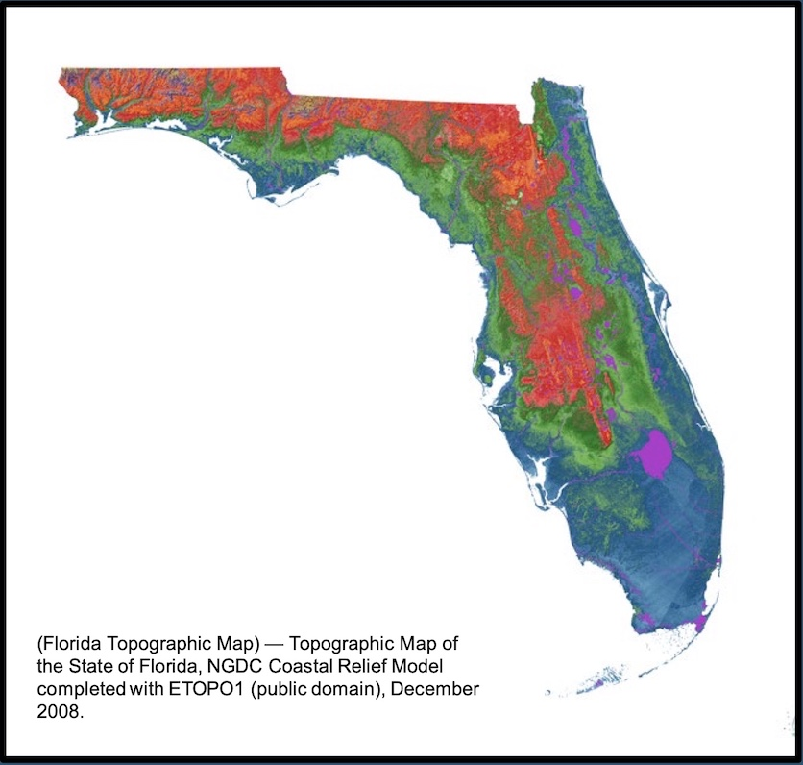
Fig. 1. Upland elevation ranges in orange to red (100-250 ft.) and dark red to brown (250-345 ft.)

Generally, the trails would traverse higher ground through virgin pine and hardwood forests with less undergrowth, rather than swampy terrain with dense vegetation and standing water. It makes common sense that people native to any wilderness figure out the pathways of less resistance. Even where trails are less direct, they are nearly always preferable to bushwhacking. Although the general routes of both expeditions roughly followed the higher terrain well inland (Figure 1), the Narváez troops initially used trails closer to the coast in hopes of reconnecting with their ships.
With no map to follow, the Spaniards measured their progress in terms of distance traveled at an estimated rate, expressed as leagues—essentially the distance a man could expect to walk in an hour. In 16th century Spain, two different league measurements were used: the common league (legua común) of about 3.46 miles (5.54 km), and the statute league (legua legal) of 2.6 miles (4.16 km). Most likely, both expeditions used the common league units to express distances traveled. Clearly, the rate of a man walking can be highly variable, depending on his condition, his footing, the terrain, and the circumstances. Achieving the 3.46 miles-per-hour rate of a common league would normally entail a brisk walk over flat ground. But that is a pace very hard to maintain for a large group of tired, hungry, and somewhat infirm men carrying their gear over unfamiliar terrain in a hostile environment.
The Narváez force began their march to Apalache with minimal provisions of two pounds of biscuit and a half pound of bacon per man. That, and foraging en route, had to sustain them for the first 15 days. Such a group would have been lucky to achieve half of the common-league rate, day after long day. In fact, Carson (2021) notes that, according to Cabeza de Vaca’s account, the Narváez expedition traveled 280 leagues (969 miles) from Tampa Bay to St. Marks, when the distance along the coast is more like 66 leagues (230 miles). Even doubling that to allow for a trail route farther inland, it is a huge discrepancy. Nevertheless, historians have sometimes tried to use the reported league distances alone to justify specific locations that the Spaniards may have visited. I consider all of the reported league distances questionable—more so for the longer marches with greater hardships.

Geographical context

In the Apalache province, there are two distinct regions of elevated, hilly terrain, separated by the upper St. Marks River (Figure 2). The southern boundary of that terrain is the Cody Escarpment, an ancient interglacial shoreline. The sandy, flatter lowlands to the south, underlain with limestone, are called the Woodville Karst Plain. In the 16th century, according to Hudson (1997), the eastern and western regions of this hill country were different chiefdoms, with principal villages of Ivitachuco and Anhaica, respectively. The eastern village that Narváez occupied in 1528 may have been Ivitachuco. Archaeologists have established that Soto occupied and overwintered in Anhaica farther west (in Tallahassee) during 1539-40.
The upland Red Hills region which the Spaniards had reached extends from the Withlacoochee River westward to the Apalachicola River, north to the Georgia border, and south to the Cody Escarpment. The Red Hills around Tallahassee is terrain of rolling topography with lakes, streams, and sinkholes that connect to the underlying limestone bedrock. It has iron-rich soils of red clay, silt, and sand that supported the Apalache natives’ productive fields of corn, beans, and squash. Higher elevations are well over 200 feet above sea level. Along the escarpment, the downward slopes to the coastal plain can be steep in places. The change in vegetation is dramatic: North of it, longleaf pine forests dominate the uplands with mixed hardwoods around streams and lakes; in the coastal plain to the south, pines cover the higher ground with palms and cypress common in swamps and wetlands. The vast intertidal zone along the coast is mostly covered with needlerush and cordgrass. The Narváez army would find travel in the coastal lowlands at times slower and more difficult. That landscape, compared to native farmlands in the hill country, was relatively poor in food resources for Spaniards not prepared to live off the marine environment.
Besides the descriptions in the CdV account, terrain features are important in tracing the Narváez expedition’s route from the upland village they occupied in 1528 to their final campsite near the coast. Accounts of the Hernando de Soto expedition in 1539 also help to corroborate the proposed BoH location. The proposed routes of both expeditions (Figure 2) will be discussed in turn.

Pánfilo de Narváez Expedition, 1527-28

The Naváez expedition’s arrival on June 25, 1528, at a principal, eastern Apalache village—possibly Ivitachuco—was not auspicious. During the prior two months’ march through a hostile wilderness, the men were exhausted, hungry, and sick or wounded in many cases. Nearing Apalache, they came to a wide, deep, and swift river (the Suwannee), where they had to build a “canoe” to ferry across nearly 300 men and their gear. (See the Note on p.19.) This was the second river crossing CdV describes, the first being the Withlacoochee, which they crossed by swimming and on rafts. These were tricky and dangerous operations for men and horses. With their force divided and preoccupied, they were more vulnerable to attack. What the Spanish accounts say—or don’t say—about crossing other water bodies is key evidence in this story.
After seven more days of difficult travel through great forests of trees “marvelously tall” (and through the Aucilla River swamps), they came “within sight” of Apalache. As CdV described it¹, they were grateful that:

…the great hardships we had endured would be finished, for our road had been long and bad, and we had endured great hunger. There were many among us who, beyond the great fatigue and hunger, were dealing with wounds made on their backs from carrying their weapons, besides other things that occurred. But on seeing ourselves arrived where we wished to be, and where we were told so much sustenance and gold would be, it was as if a great part of our labor and fatigue had been taken away.

They occupied the first village they came to, which had “40 huts”. There was abundant corn in the native fields but no sign of gold or other riches they had hoped to find there. While they investigated the surrounding area, they held the village chief hostage, but that did not subdue the Apalaches. They were proving to be skillful and fearless warriors who could often hold their own against Spanish steel and horses. Both normally gave Spanish troops a big advantage in their conflicts with native peoples in the New World. But the Narváez horsemen had already realized the limitations of mounted combat in the thick forests and hilly terrain, from which the natives could shoot arrows at them with impunity. The Spaniards marveled at the power of their bows.

¹ La Relación translation by Carson, 2021

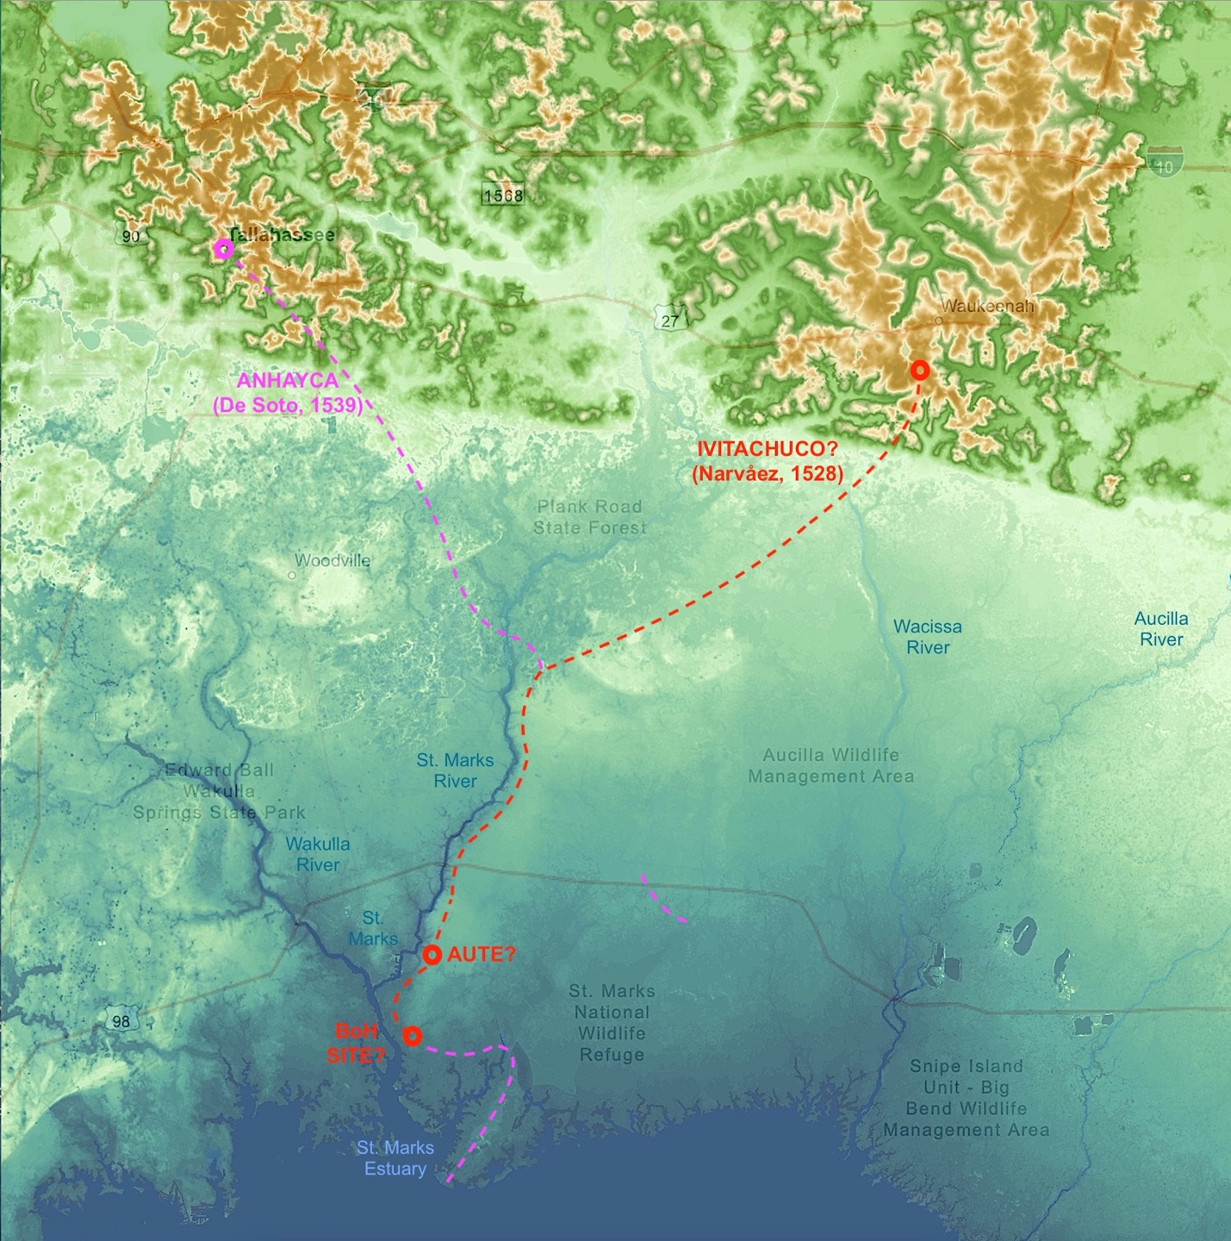
Fig. 2. Proposed routes of Narváez (red) and Soto (magenta) expeditions in Apalache. Similar routes were followed along the St. Marks River. Dotted lines indicate general directions. The escarpment boundary is especially dramatic in eastern Apalache.(NOAA Sea Level Rise Viewer, 2022)
https://coast.noaa.gov/dataviewer/#/imagery/search

As time passed, their dangerous occupation of the village became increasingly pointless.

We [the Narváez troops] were in this village 25 days, during which we made three trips into the country and found it very thinly populated and very bad for travel, because of the bad crossings, forests, and lagoons it had. We asked the chief that we had detained, and the other Indians that we had brought with us, who were neighbors and enemies of theirs, about the manner and population of the country, the quality of its people, and about supplies and everything else about it. They responded to us, each one for himself, that Apalache was the largest village in all that country, and that further on there were fewer people who were much poorer than them, and that the land was not well-populated, and its inhabitants were very scattered. Even further in, there were large lagoons, dense thickets, and vast unpopulated deserts.

The forays into the countryside were probably made by armed horsemen. Given the ferocity of Apalache attacks, it seems unlikely the recon parties would have ranged too far from their village base, or had any friendly Apalaches to guide them. The villagers probably wanted to discourage their enemy from any further exploration, especially westward toward the villages of Anhaica in today’s Tallahassee Hills.
There is no indication in the CdV account that Narváez’s men ever continued westward through the upper St. Marks River swamps to the next group of highlands and the larger villages of Anhaica, as Soto did 11 years later. Today, that route would roughly follow Highway 27 from Waukeenah to Tallahassee (Figure 2). For the disappointed Narváez men, it would have meant another 20 miles or so of hard travel and more native attacks. With no apparent knowledge of Anhaica and feeling disillusioned about their conquest of Apalache, they would have had little incentive to press on westward. It also would have seemed fruitless to continue their dangerous occupation of the village where they were. This stage of the expedition had reached a dead end.

We then asked them about the country that was to the south—about the villages and resources it had. They said that nine days’ travel in that direction toward the sea, there was a village called Aute. The Indians there had much corn, and that they had beans and gourds [squash], and that by being so close to the sea, they caught fish, and they were friends of theirs.

I infer from this that the upland Apalaches—both eastern and western—communicated with their lowland brethren at Aute over a familiar network of trails. Nothing like this invasion had ever happened to their people, and the news of it must have spread quickly. The Aute natives were forewarned of the Spanish enemy coming their way. The invaders arrived to find the village burned, and the native attacks resumed. The Apalache leaders must have considered the warlike Spaniards a grave threat to their way of life, one that required a unified response. Promoting the move to Aute near the coast might have been an Apalache strategy to lure the Spaniards away from their main populations and toward the remote coastal swamps, where they would be more vulnerable to starvation and attacks. From the Spanish point of view, if they could reconnect with their support ships at the coast, they could reprovision and possibly restart the expedition farther west.

On July 30, the Narváez expedition departed the Apalache villages and headed southward in search of the Gulf Coast. The trek to the coast was difficult and still dangerous, as native attacks continued en route.

[We] decided to leave there and go look for the sea and that village of Aute that they had told us about. We therefore left at the end of twenty-five days after our arrival.
The first day we passed those lagoons and crossings without seeing an Indian. But on the second day, we came to a lagoon that was very hard to cross because the water came to our chests and it had many fallen trees in it. We were in the middle of it when many Indians, who were hidden within the trees, so that we could not see them, attacked us.

CdV describes the fighting among lagoons and fallen timber, where native warriors with powerful bows fired at them from all sides, wounding several Spaniards. Evidently, they had been led into an ambush by a false guide. The lagoon crossings and attacks continued on the third day, no doubt slowing them down. Later in his account, CdV recalls that on that third day:

…we had discovered a very large river that we had given the name, River of the Magdalene.

Carson (2021) says this name very likely means the Spaniards discovered the river on the feast day of Mary Magdalene, July 22 (Julian date), which would have been the third day of travel from the Apalache village to Aute. Based on the proposed location of the Narváez-occupied village (possibly Ivitachuco), on the third day they likely saw the springs area of the upper Wacissa River, where the channel is up to 100 yards (91m) wide for over four miles (Figure 3). It was noteworthy because the Spaniards had not seen a river that size since the Suwannee about a month earlier. Unlike the St. Marks and Aucilla Rivers that flow out of the hills west of Tallahassee, the Wacissa originates at the base of the Cody Escarpment as a series of first-magnitude springs. The slope of the escarpment down to the Woodville Karst Plain is particularly steep in that area. (Figure 2). CdV even notes that on the third day of travel:

When we came out onto the plain, they were still following us. We turned on them in two groups and killed two Indians. They then returned to the forest, and we could not do them any more harm or damage.

In other words, the Apalaches returned into the forested hills of the escarpment, where they had the tactical advantage. The Spaniards must have welcomed the flatter “plain” where they could defend themselves better and travel faster. Two days of attacks had surely limited their progress.
It is significant that CdV says nothing about their crossing the broad Wacissa channel, which would have taken a major effort for their battered troops. The trail they followed might have skirted around the north side of the first springs where the river narrows in places to little more than a stream, easily crossed.
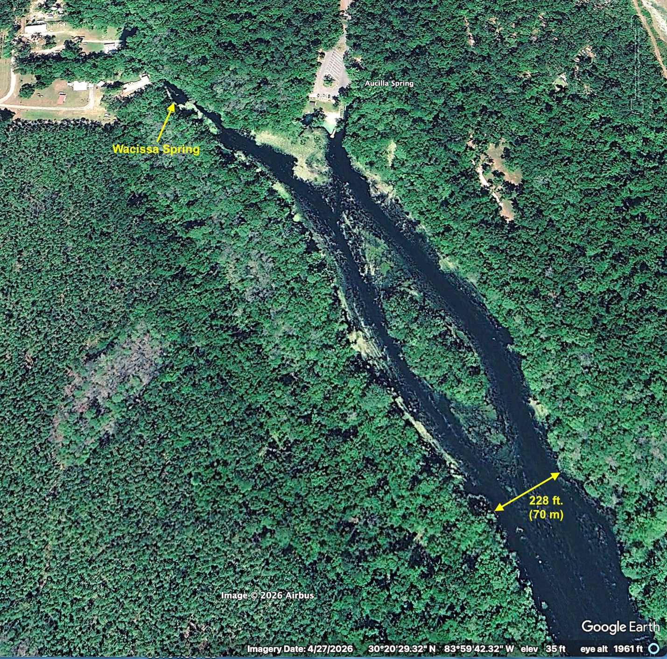
Fig. 3. Wacissa Spring and River. The channel of that width or greater continues for four more miles.

Their route continued along trails going southeasterly toward that part of the coast where the St. Marks and Wakulla Rivers join to form a large estuary and where a major point of forested headland projects into the Gulf of Mexico (now Lighthouse Point). Undoubtedly, those were prominent landmarks for native peoples since ancient times. They were accessible largely along higher ground in a coastal zone that was otherwise low and marshy. Logically, the natives would have taken advantage of that and established trails down the eastern side of the St. Marks River to the estuary shore and to the headland beyond it (Figure 4).
Figure 5 illustrates the proposed trail that both expeditions followed after reaching the St. Marks River. Initially, I suspected that CdV’s “very large” River of Magdalene might be the springs area of the St. Marks River just below Natural Bridge. But that is over halfway to St. Marks, and the Narváez troops must have been slowed down by attacks in the hills during the first three days. More likely, they would have reached the Natural Bridge area on the fifth or sixth day of travel. The only other river of that size in the area is the Wakulla, which also arises from a massive, first-magnitude spring. But that is another 10 miles or more beyond the St. Marks. Moreover, any scenarios that involve the Spaniards following the Wakulla—either side of it—southward to the coast is not supported by evidence presented later.
For eight days, they followed the trail to Aute (with or without another guide) and made reasonable progress, although they were attacked again on the next-to-last day. They found the Aute village abandoned and burned, but with plenty of ripe corn, squashes, and beans in the fields.
One question to consider: If much of the proposed route to Aute paralleled the St. Marks River—and it was not the River of Magdalene—why did CdV not mention it in his account? For one thing, the St. Marks, except for the short River Rise springs area, is much smaller than the upper Wacissa, and the trail following it would have kept to the higher ground a little distance from it (Figs. 4, 5). The river might not have been visible through the bordering swamps. On the other hand, occasional side trails may have allowed men and horses access to water during the trek to Aute.
As Figure 2 indicates, the Soto detachment had to cross the St. Marks River at some point, but may not have realized it for reasons discussed later (p. 30).

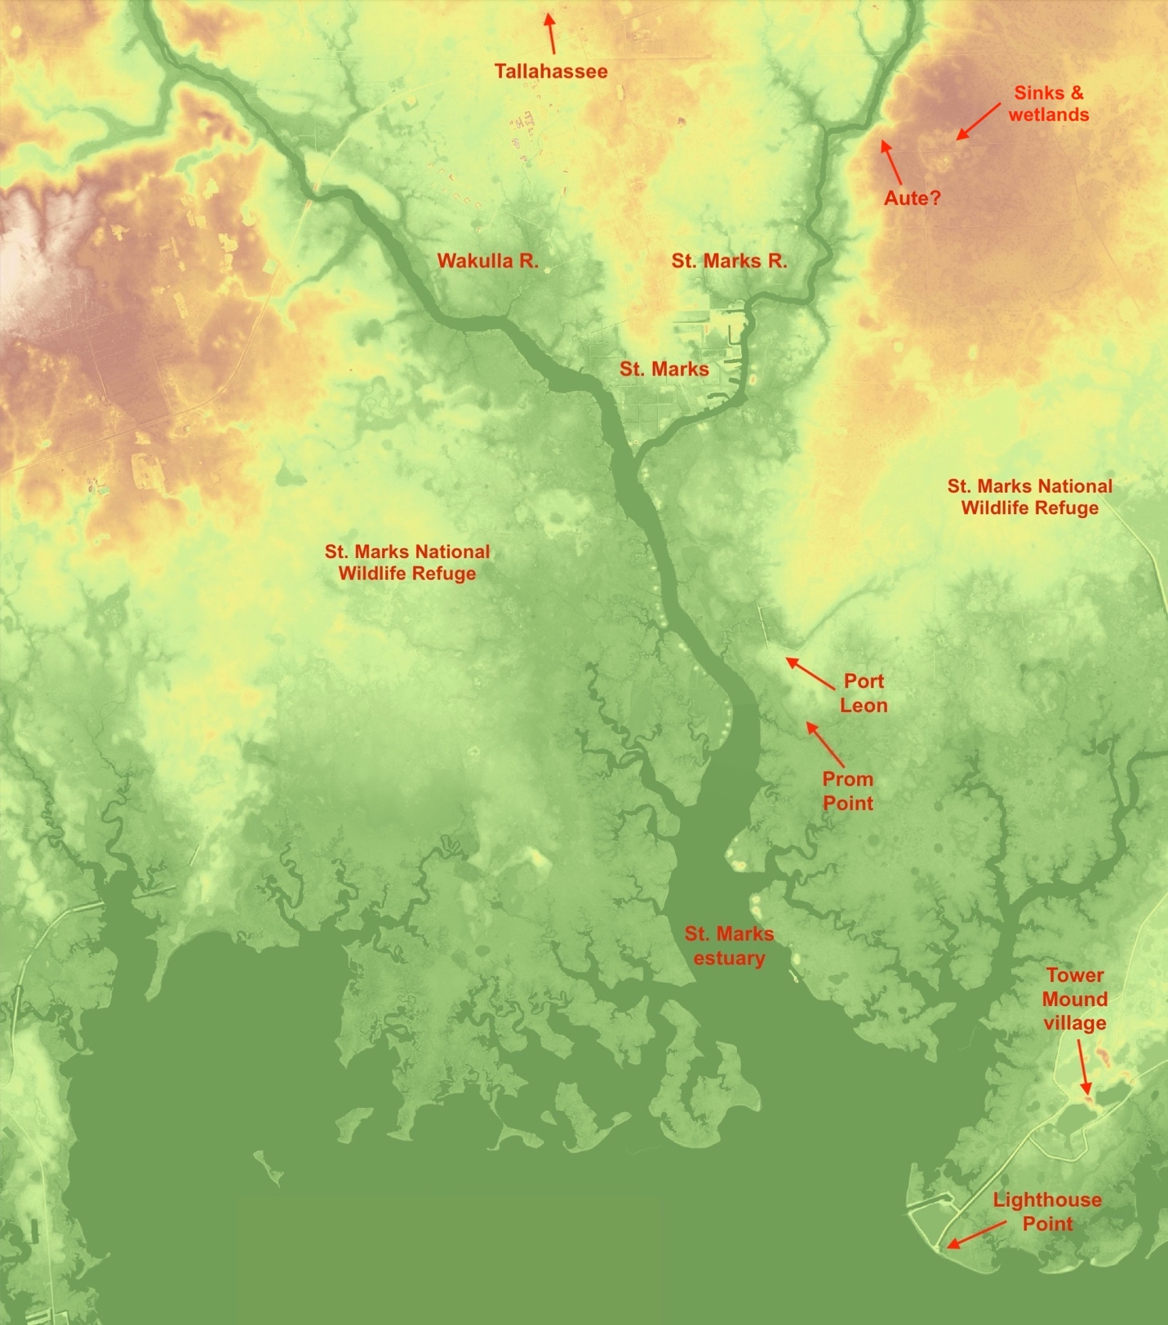
Fig. 4. Ridge of higher ground (yellow to orange, ~3-25 ft.) extending toward the St. Marks estuary.
High-ground elevations and coverage would have been greater at lower sea levels in the 1500s.
LiDAR digital elevation model. (Wakulla County 2018 DEM data obtained from
Florida Geographic Information Office, https://www.floridagio.gov/pages/lidar-resources
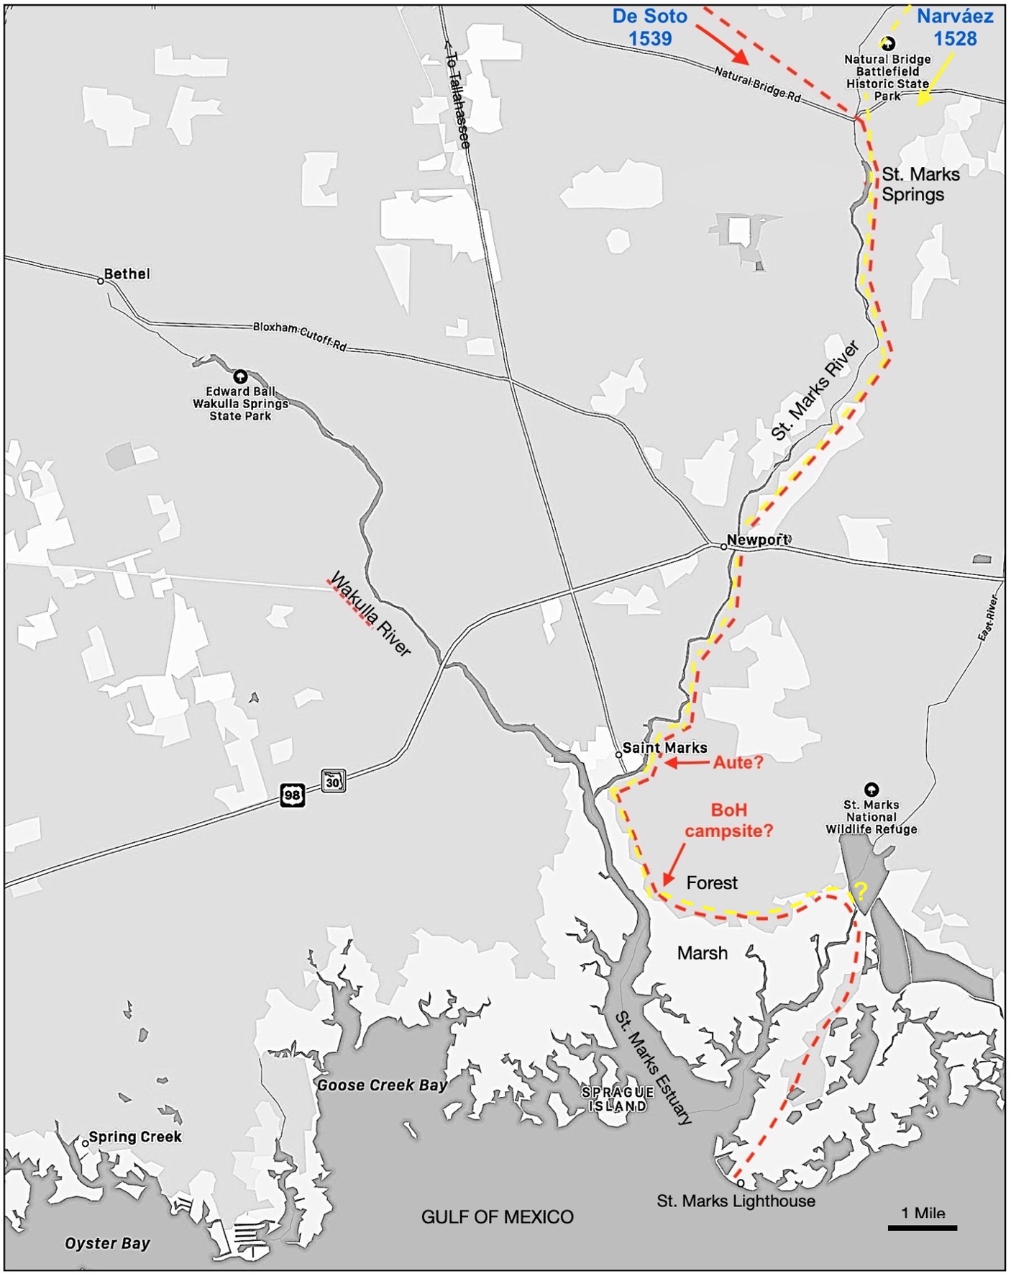
Fig. 5. Proposed lowland routes of the Narváez (yellow) and Soto (red) expeditions, with forays
beyond the BoH campsite. Soto’s 1539 exploration continued to the Gulf Coast.

We rested there for two days. After these passed, the governor ordered me to go explore the sea, which the Indians had said was quite close by. Accordingly, I left the following day to explore it, joined by the commisary, Captain Castillo, Andrés Dorantes, seven other horsemen, and 50 footmen. We traveled until the hour of vespers, when we reached an inlet or entrance to the sea, where we found many oysters, which the men enjoyed. We gave many thanks to God for having brought us here.

CdV’s choice of words in the bold-type sentences above is important. In the second Spanish publication of his account (La Relación Online, 1555), the place they reached first and found oysters was un ancón o entrada de la mar (an inlet or entrance to the sea). And on the same page he refers to ancones y bayas (inlets and bays). He distinguishes between an inlet and a bay, both of them entrances to the sea, but a bay being the larger body of water. In this case, the Bay of Horses must mean the St. Marks estuary, by far the largest body of water in Apalache that is not on the open coast. Later, when they are camped near that bay, CdV speaks of their men gathering shellfish in los rincones y entradas de la mar (the coves/nooks and entrances of the sea), suggesting inlets off the bay. Much later, when they were sailing along the open coast, CdV says they entered ancones y bayas (inlets and bays), maintaining his distinction between narrow and larger entrances to the sea. All of this implies that the Spaniards’ initial contact with the tidal shoreline was probably at an inlet (ancón), even if they found oysters along the estuary (baya), as well.
Note that CdV does not say the 61-man reconnaissance party crossed any river before reaching either Aute or the oyster inlet. It suggests that the whole journey southward was NOT between the St. Marks and Wakulla Rivers, which converge at the point of land where St. Marks is today. Over a century later, the Spanish built Fort San Marcos de Apalache on that strategic site, but that is not a plausible location for either Aute or the oyster inlet. The water at that river junction is far too fresh for oyster growth, as it most likely was five centuries ago as well. The St. Marks and Wakulla Rivers are fed by first-magnitude limestone springs, and the lower sea levels then would have reduced tidal influence on the rivers. That means the Spaniards’ oyster inlet had to be some distance down the estuary from St. Marks, probably where the waterway broadens, salinities are higher, and oyster reefs exist today.

The aerial image in Figure 6 indicates the proposed route of the reconnaissance party, shown as skirting the present forest boundary. The forest edge, now mostly within a quarter mile of the estuary, would have been much closer to it in the 1500s. (See Note on p. 16). Logically, they would have continued following that edge of higher ground, paralleling the estuary, until they came to a point of forest where the forest boundary turned east, and they could see only marshes southward to the horizon. That is “land’s end” with respect to the forest boundary continuing to follow the estuary shore. I’m calling that unnamed promontory Prom Point for convenience. Passing close by it is Prom Inlet, which branches off the estuary a quarter mile west. Two branches at its upper end extend another quarter mile to the east of Prom Point. The inlet drains the surrounding marsh, including inputs from karst sinkholes which overflow periodically, flooding large areas of the marsh. Recent overflows are visible in Google Earth images of 3/1994, 1/1999, 3/2006, 1/2007, 11/2007, 5/2014, 12/2015, and 1/2020. That suggests Prom Inlet has a long history that is less dependent on sea level changes than some purely tidal inlets, which are simply channels draining the marsh on outgoing tides.
The Spaniards’ views from Prom Point could have resembled those I photographed in Figure 7. To stand there, looking from east to west across the marsh, is to appreciate how dismayed the Spaniards might have felt. An observer sees a vast expanse of waist-high needle rush and spartina grass stretching to the horizon. From ground level, it is impossible to see the St. Marks estuary a quarter mile to the west, or even Prom Inlet 50 yards away. Most of the marsh is flooded and soggy during high tides. It is not likely the Spaniards would have struck out across the flooded wetland that seemed to go on forever. Had they tried to, they would have run into more and larger inlets long before reaching the coast.
After the oyster-eating event, CdV decided to send a smaller detachment to look for the open coast where they might contact their ships:

The next morning, I sent 20 men to inspect the coast and take a look at its layout. They returned the following night. They said that its inlets and bays were very large and reached far inland, which greatly hindered their discovery of what they wanted, and that the coast was very far from there. With this new knowledge, and seeing how poorly organized and prepared we were for exploring the coast, I returned to the governor.

Most likely, the recon party would have continued following the forest-marsh boundary, hoping it would eventually lead to the open coast. From Prom Point looking southeast, they could see another promontory pointing farther south—an encouraging sign (Figs. 6, 7). They could not have known that, beyond the next promontory and two others, the forest boundary keeps turning away from the estuary as it tends northeasterly. Even worse, the boundary is broken up by mud flats, sinkholes, and swamps. The Spaniards had no native guide to lead them over trails that would avoid those terrain problems. We can’t know how far the recon party traveled in one day or what other bodies of water they saw. But if they stayed committed to that choice, they might have reached the broad channel of the East River and some inland lagoons—perhaps the ”bays” they saw. The straight-line distance from Prom Point eastward to the upper East River is about two miles, but over five miles along the convoluted boundary. Apparently, the Spaniards did not know that, across the East River, a ridge of forested higher ground angles southwestward for four miles to a rocky shore (now Lighthouse Point) at the mouth of the St. Marks estuary—something a local native guide would surely have known. But with no guide, perhaps they did not want to risk or endure further reconnaissance in that hostile landscape. This scenario gains support from the Soto accounts discussed later.

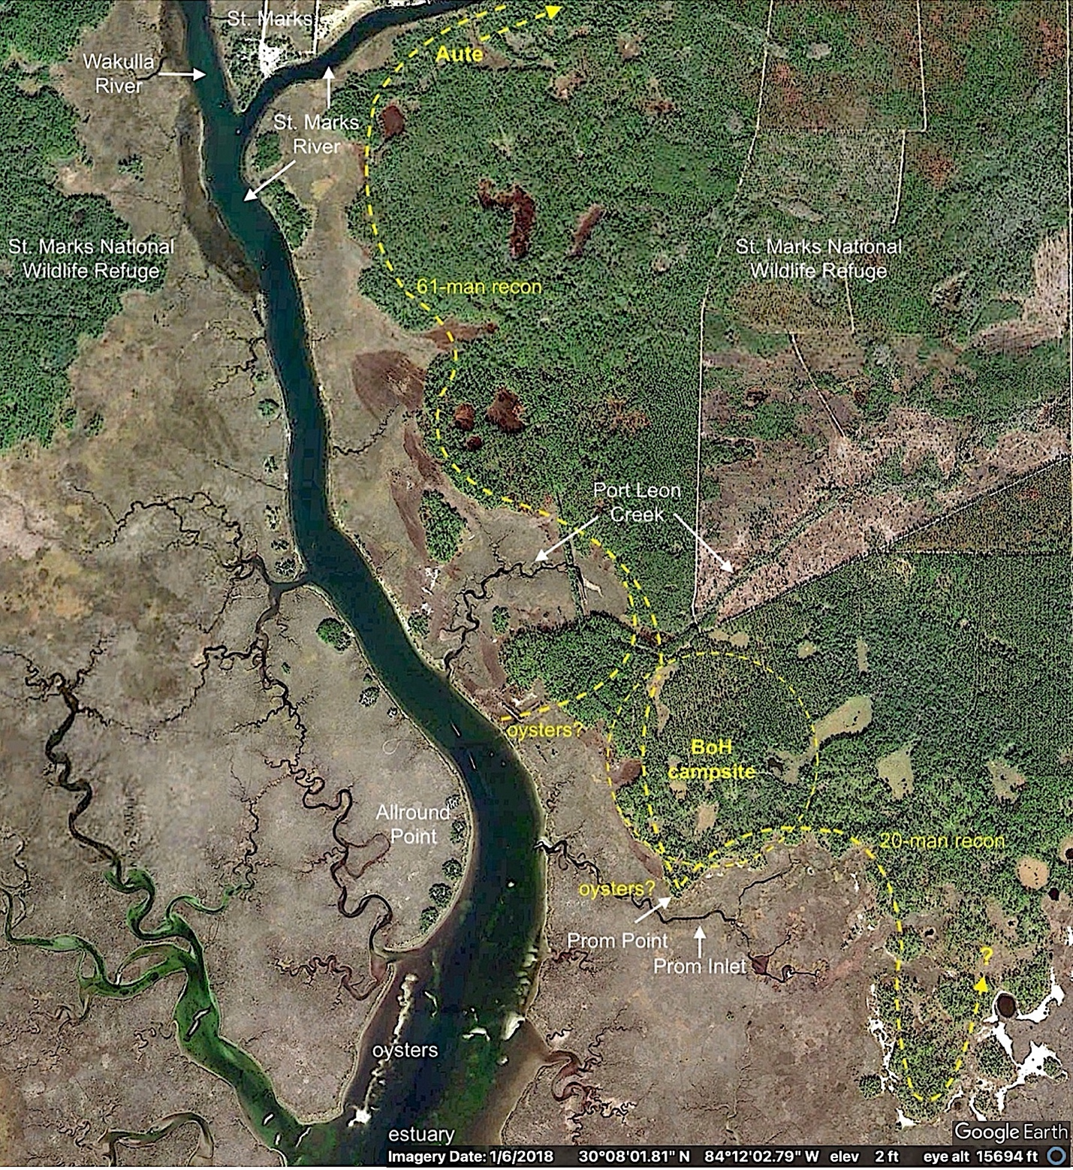
Fig. 6. Proposed Spanish route and landmarks around the Bay of Horses (St. Marks estuary.

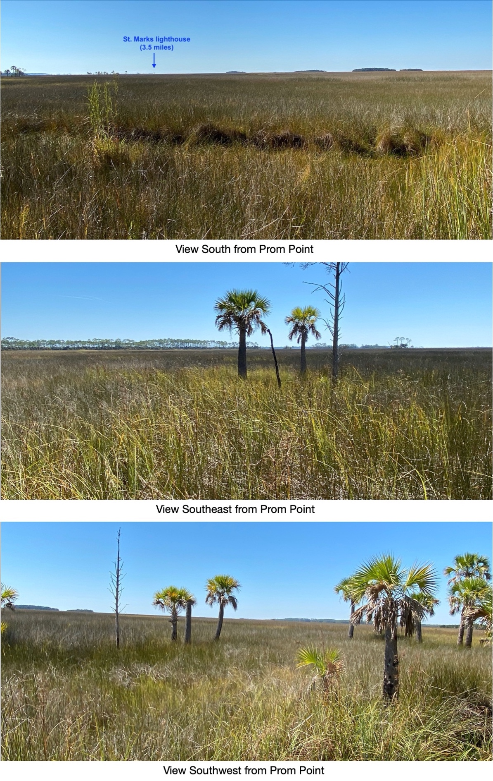
Fig. 7. Views from Prom Point. Tree islands in the south view above are growing
on modern dredge spoil along the estuary, the shoreline of which is not visible.

Note on the history of the coastal environment around St. Marks. In my conjecture about what the Spaniards might have seen and experienced in their travels, I have assumed the coastal landscape around St. Marks has not changed drastically since the early 1500s. The climate then was somewhat cooler during the Little Ice Age (LIA), generally 1400 to 1900, with the extremes of cooler, drier weather occurring from the mid 1600s to the early 1700. CdV even mentioned the “very cold” climate in Apalache—at least compared to that of central Florida—during the mid-summer of 1528. But in northern Florida, no great ecosystem changes should have occurred primarily due to the LIA.
Numerous hurricanes have flooded that coast with storm tides over the last five centuries, but their erosive effects on the upland-wetland boundary are moderated by the shallow waters offshore, protective marshlands, and the limestone bedrock underlying the area. The Category-5 Hurricane Michael that struck the coast near St. Marks in 2018 caused no conspicuous changes in that boundary along either side of the estuary.
However, rising sea levels, accelerated by global warming, have moved the forest boundary significantly. Since the 16th century, global sea levels have risen as much as 11 inches (Kopp, R. E., et al., 2016), about half of that since 1940 (Church, J. A. and N. J. White, 2015). Remnant palm and pine trees in the marshes (Figure 7) are visible evidence of recent sea level rise. The resulting shift in the upland-wetland boundary around Prom Point is evident in this overlay of a 2018 Google Earth aerial photo with a 1940 Coast & Geodetic Survey map (T-sheet 5806: https://geodesy.noaa.gov/pub/Shoreline/T-Sheet%20Raster%20Images/nongeomanu_index.html). Note that in 1940, the forest of Prom Point grew much closer to the inlet. There was also a large island of upland vegetation south of the inlet, which has since nearly disappeared (Figure 8).
In 1528, sea levels were even lower by several inches. The forest around Prom Point might have grown up to the edge of the inlet, which would have provided direct access from high ground to a navigable waterway. That would have provided direct access from high ground to a navigable waterway. The Spaniards’ five heavy boats of about 40-foot length could have been launched even without the help of horses, which they had eaten by then. All of this suggests the campsite was located along a forest boundary that, in 1528, was much closer to navigable waters, such as the Prom Point inlet or the St. Marks estuary—their so-called Bay of Horses.

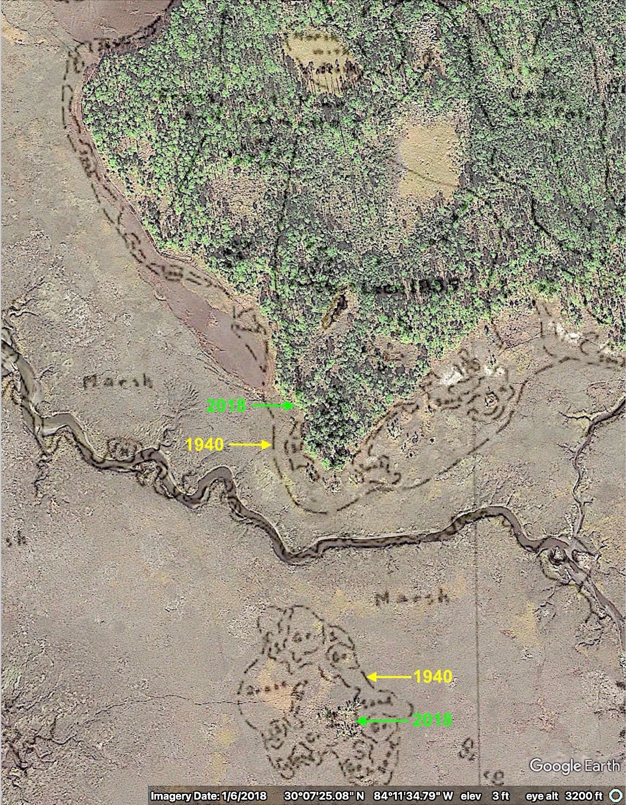
Fig. 8. Shift in the upland-wetland boundary at Prom Point from 1940 to 2018, due to
a global sea level rise of about six inches. (Church and White, 2011)

As the coastal reconnaissance was going on, Narváez was still at Aute with the main force. They were in even worse shape with more illness and wounds after another native attack the previous day. Cabeza de Vaca reported to him the discouraging results of his explorations from the oyster site. Apparently, they thought the only realistic option was to move the army there and try to recover their strength.

We left the following day and traveled all day until we arrived where I had been [at the inlet].. We went on the trail with extreme difficulty, because neither were are the horses sufficient to carry the sick, nor did we know how to cure them. They suffered every day; it was a very painful and pitiful thing to see the need and hardship that they were in. The further we went, I saw how unprepared we were for going forward, because we did not know where to go.

Note again, there is no mention of a river crossing. For that battered and sick group, it would have been extremely difficult, even in the best of circumstances. River crossings were not trivial, especially if they might be attacked. They did make it to the oyster inlet, where they established a campsite. There were some natural advantages to the area they had chosen (Figure 6).
- The higher ground they had followed southward ended in a couple of promontories with marshland on three sides, offering more security from surprise attacks;
- Fresh water was available from Leon Creek and nearby sinkholes;
- The virgin pine forest provided excellent lumber for building boats (as it turned out);
- The navigable Prom Inlet was just south of (then adjacent to?) Prom Point;
- Oysters and other seafood were available from the inlet and/or nearby estuary;
- The Aute village with more food supplies they could raid was not far away;
- They could still hope to find the coast and their ships via the estuary.
That became the expedition’s Bay of Horses (BoH) campsite for the next seven weeks, while they constructed five boats in an attempt to escape to Spanish territory in Mexico. In his account, CdV describes how totally unprepared they were to build the boats. (See Note, p. 19.)

It seemed impossible to everyone, because we did no know how to make them, neither had we any tools, iron, forges, oakum, pitch, or rigging. In the end, out of all of the many things that would be needed, we had none, nor did anyone know anything about their fabrication.

CdV further describes how they improvised with handmade tools and local materials, even reforging their personal gear into fasteners. One other essential thing was hard to find at first.

Such was the land in which our sins had placed us, that it was with great effort that we were able to find stones for ballast and anchors for the boats, for we had not seen one in all of it.

Although the whole St. Marks region is underlain with limestone, in my 2023 exploration of the proposed campsite area, I saw none on the surface. Perhaps the Spaniards finished one of their boats before the others, to test their design and construction, and used it to explore the banks of the estuary for limestone outcrops. In fact, about a mile up the estuary, the Spanish developed a limestone quarry in the early 1700s (Figure 21). It’s tempting to think that is where the Narváez men finally discovered some exposed limestone.

Note on the boat-building project. The boat-building episode at the BoH campsite is a distinguishing feature of the Narváez expedition. Given their desperate situation, it was a major accomplishment. Cabeza de Vaca claimed they had none of what they needed to build boats, but surely he exaggerated. Two months earlier, on the way to Apalache:

That night, we came to a river [the Suwannee] that was very deep and very wide, and the current very strong. Since we could not cross over on rafts, we made a canoe for it. We took a day to cross it. If the Indians had wanted to offend us, they could well have hindered our passing.

By “canoe”, he surely meant something more than a two-person native canoe made from a hollowed-out log. Only a very large canoe, or maybe two of them lashed together, would suffice for carrying 300 men with their gear and towing some 40 horses across the Suwanee in one day. The craft they made might have been a simple flatboat of the Spanish barca chata design used at St. Augustine in the 1600s. https://www.staugustinelighthouse.org/2021/08/02/a-new-barca-chata-and-a-history-of-boatbuilding-in-st-augustine/
These may be constructed from a few rough planks with interior bracing. The point is, the Narváez men already had some experience in boat building before the BoH project.
In the king’s appointment of Narváez as governor of La Florida, were the requirements to build at least two settlements and two coastal forts. It is not clear how prepared or equipped they actually were to do that. At least, the freelance soldiers of the expedition would have had the means to maintain their own weapons and tack gear, as well as some knowledge of other crafts they had experienced in their towns and villages. Most of them would be proficient in basic skills for working metal and wood, because their lives depended on keeping their weapons and other equipment in good order. Some would know how, with only an axe, you could make a wooden mallet and wedges sufficient for riving (splitting) big logs into planks. https://saxonship.org/the-project/phase-2-build/ancient-tools-and-techniques/cleaving-an-oak-log-for-planking/ The tall, straight longleaf pines that occurred everywhere were perfect for this. One of the men, Álvaro Fernández, was even a carpenter by trade.
Some historians have suggested they had to smelt and forge iron into ship building tools such as saws, axes, augers, drawknives, and adzes, hammers, and anvils. That seems beyond their capabilities in those primitive conditions. They already had the tools or didn’t.
The five Narváez boats (barcas) were built close to the eastern shore of the estuary or along one of the marshy inlets leading into it. The main requirement was close proximity of forest to the waterway: The huge, straight, longleaf pine trees (Figure 19) made excellent lumber. Although CdV says very little about how the boats were built and nothing about their design, a great deal of thought and planning must have gone into the project. Their lives depended on building sturdy, seaworthy boats that would accommodate all the men, their gear, and supplies.
Nautical historian Steve Harris (2019) has proposed a simple design that was in line with CdV’s description, was within their means to build, and would have met their needs (Figure 9). He designed the model in consultation with other nautical historians and marine archaeologists.³ It probably would have been a much-simplified version of the bergantines that were widely used in the 16th century New World for coastal exploring and armed reconnaissance (Harris 2021). The two Soto vessels that met his troops at the Bay of Horses were bergantines.

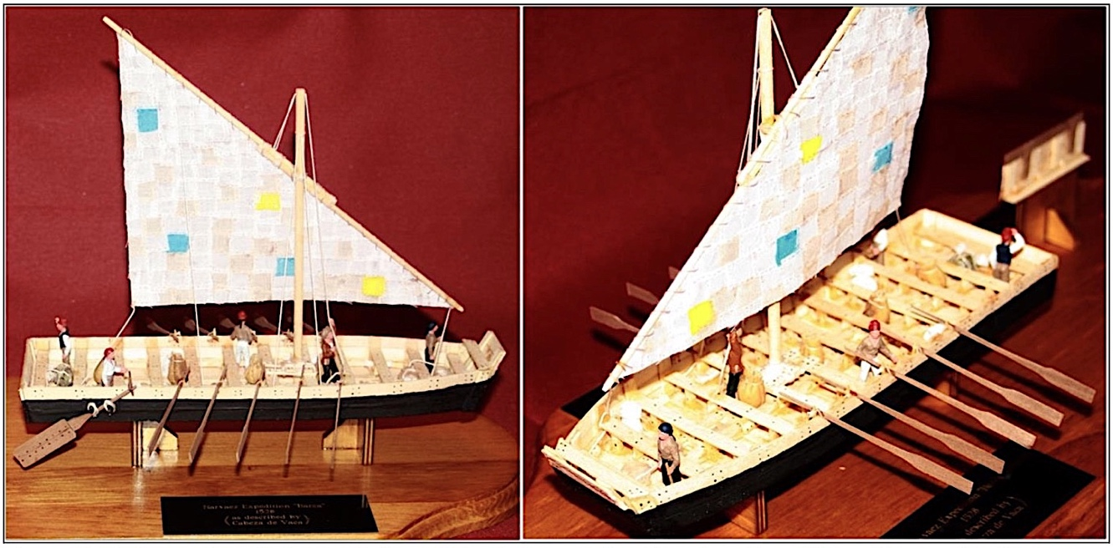
Fig. 9. Proposed model of Narváez barcas built by Harris (2019) for the San Marcos de Apalache State Park Museum at St. Marks. (Steve Harris photo by permission).

Some translators and historians have used the term barges to describe these barcas, although other Spanish words would be more appropriate (barcaza, gabarra, falúa). In modern times, the term barge suggests a boxy, flat-bottomed cargo vessel that is towed, not self-propelled. To the extent that writers simply mean the Narváez barcas were flat-bottomed and blunt-ended, then “barge” could be close enough.
Other writers have suggested the barcas they built were actually rafts (Reséndez, 2007). In my opinion, heavy log rafts, which he estimated might weigh 15 tons, could not be sailed and/or rowed for over 800 miles along the Gulf Coast in six weeks. After shore landings, relaunching log rafts into heavy surf would be all but impossible, especially by the Spaniards in their depleted state. What’s more, in the late-autumn storms of the Gulf of Mexico, starving, poorly-clad men would quickly die of exposure on rafts that were constantly awash.

Despite the campsite’s advantages, the location did not protect them from surprise attacks.

During this time, some went to the nooks and inlets of the sea to gather seafood. The Indians struck them twice. They killed ten men in view of the camp, without our being able to help them. We found them shot with arrows all the way through. Although some of them were wearing good armor, it was not enough to withstand, because nothing was, because they shot with such skill and force, as I said above.

These were among the ~36 men who had died at the campground during this period. Presumably, all were buried on the highest ground within the campsite. Perhaps their graves were somewhat protected with coverings of oyster shell or limestone.

I should note here that some writers have suggested the Bay of Horses might be Ochlockonee Bay or even Apalachicola Bay, but these do not account for this passage, as the Spaniards began sailing along the coast:

That bay we left from is named the Bay of Horses. We went along those inlets for seven days, in waist-deep water, without seeing any sign of anything like a coast. At the end of these days, we came to an island that was close to the mainland…

That perfectly describes the convoluted, marshy coastline of Oyster Bay between St. Marks estuary and Ochlockonee Bay. The Narváez men were inexperienced sailors in crude, overloaded boats, so they might have traveled cautiously and close to shore through the confusing maze of shoals and marshy islands, a distance of 20 miles or more. If they were trying to follow the forested shoreline they could see beyond the marsh, that likely involved some backtracking out of inlets that led nowhere. Not surprisingly, it took them a whole week. Eventually, they might have found their way into a passage between Piney Island and the mainland.

Two leagues from there, we passed through a strait where the island met the mainland. We called it Saint Michael, because we made through it on his day. Leaving it, we arrived on the coast where, with the five canoes I had taken from the Indians, We repaired the boats somewhat, making waist boards of them and adding them so that they rose two palms above the water.

In another five miles or so, they would have emerged into open water just north of Ochlockonee Bay, where the marshes end, and forests grow close to the shore. With their confidence growing and their boats made more seaworthy with waist boards, they continued south across the bay mouth and rounded Alligator Point into St. George Sound and the Gulf Coast beyond. That would have been a welcome sight, but only the beginning of their arduous voyage.

Note on historical maps. Before his expedition to La Florida, Narváez knew about the two earliest maps of the Gulf of Mexico. One, made by Alonso Álvarez Pineda in 1519, was a bare outline of Gulf shorelines with few details but fair accuracy, considering the crude state of navigation at that time (Figure 10a). The Rio del spiritu santo label on the northern coast was later construed as representing the Mississippi River since the map position is appropriate. Another map of 1524, including information Hernán Cortés gained from Montezuma, also portrays La Florida and Rio del spiritu santo (Figure 10b). Narváez’s license from the king to conquer and govern the northern Gulf Coast territory, from Florida to Mexico, was based mainly on the Pineda map.
The so-called De Soto-Moscoso map of 1539-40 (Figure 11) depicts many more named rivers, Spanish missions, and coastal features such as Rio del spiritu santo, though many labels are not consistent with later names. It’s important to realize that, without any ability to determine their longitude, the Spanish could only guess at the east-west distances on these maps. Narváez grossly underestimated the distance from the Bay of Horses to Mexico—a fatal error.

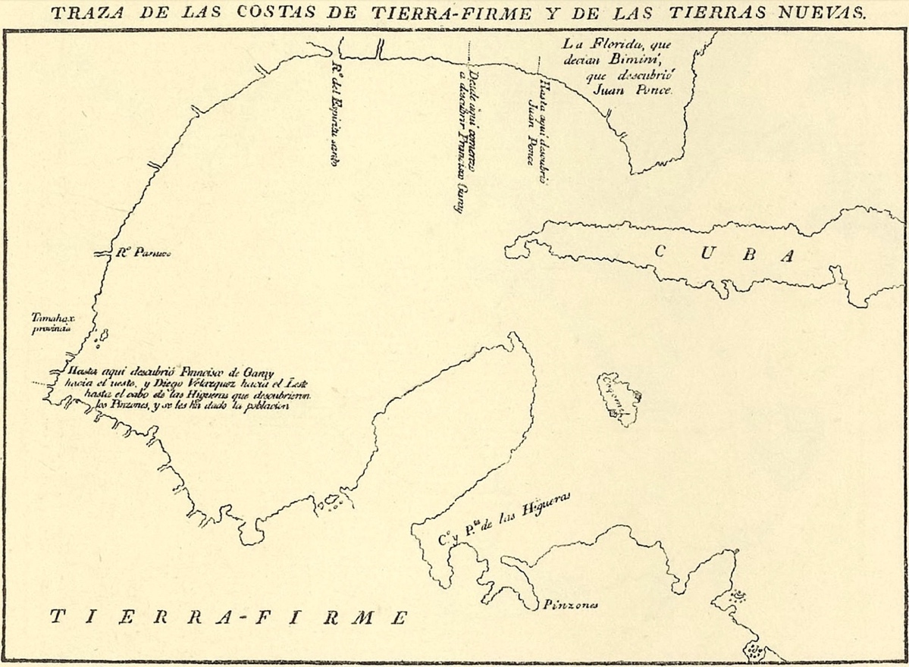
Fig. 10a. Facsimile of Álvarez Pineda 1519 map of the Gulf of Mexico (After Navarrete).
https://en.wikipedia.org/wiki/Alonso_Álvarez_de_Pineda

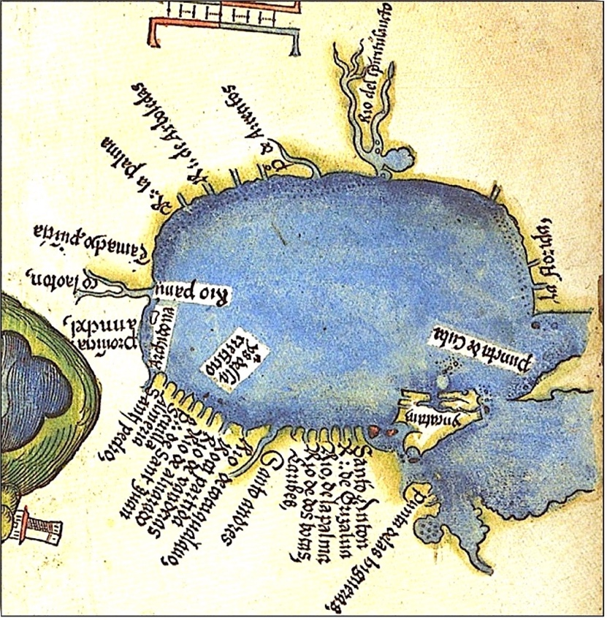
Fig. 10b. Hernán Cortés 1524 map of the Gulf (inverted with north at top).
https://commons.wikimedia.org/wiki/File:Map_of_Tenochtitlan_and_Gulf_of_Mexico,_1524.jpg
The 1591 map of De Bry and Le Moyne (Figures 12a,b) may be the first confirming that the Narváez expedition came down what clearly represents the St. Marks River estuary. The map depicts the union of two rivers (Wakulla and St. Marks) to form the estuary, placed in the correct bend of the coastline. It even shows three islands or shoals off the estuary mouth that are still there today. The labels in Latin read: Hic descendit Pamphilus Narvaez and Sinus Morquel. “Here Pánfilo de Narváez decended (went down)” and “Bay of Morquel”—Morquel referring in error to the name of Diego Miruelo, the Spanish pilot who had guided the expedition’s ships to the Tampa Bay area in 1528.

Knowing the exact location of Aute would help in relocating the expedition’s lost campsite at the Bay of Horses. The name appears on several maps published in the 17th and 18th centuries. Perhaps the earliest mention is on a 1630 map of Florida et Regiones Vicinae, Joannes de Laet. Aute is placed east of the St.Marks-Wakulla Rivers, which are unnamed but may be identifiable by their location and shapes (Figure 13). Three islands are also shown off the loop in the shoreline, apparently representing Apalachee Bay.

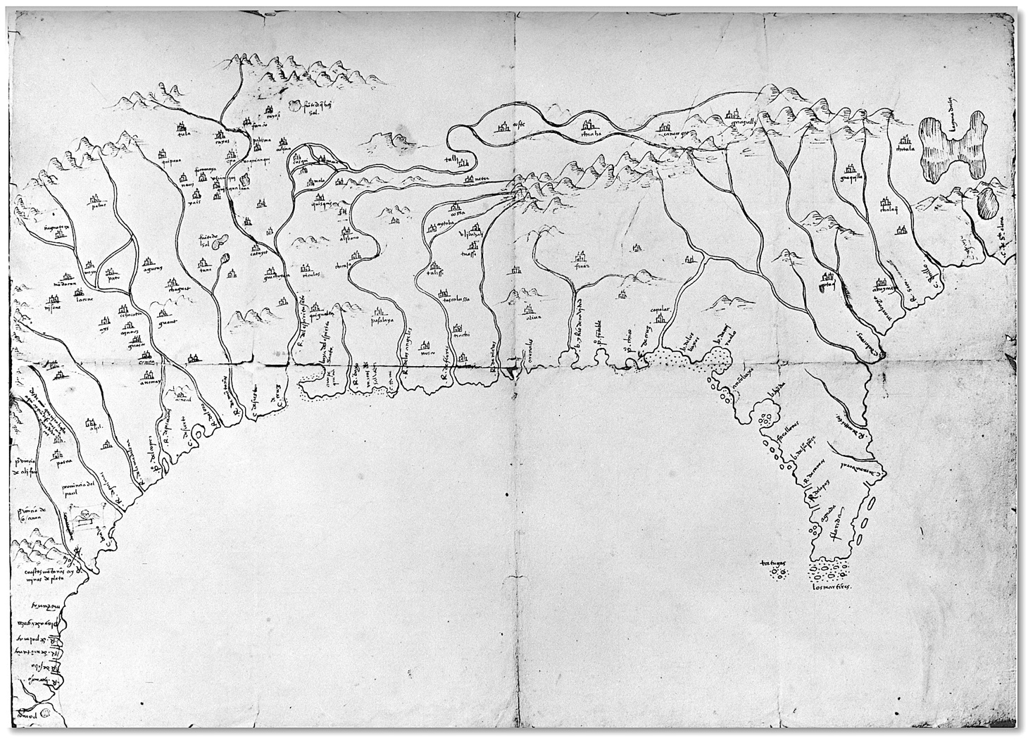
Fig. 11. De Soto-Moscoso map of 1539-40. Legend: Mapa del Golfo y costa de la Nueva Espana, desde el R~o de Panuco hasta el cabo de Santa Elena &] I De los papeles que traxeron de Seuilla de Alonso de Santa Cruz [endorsed]; https://www.myoldmaps.com/3731-mapa-del-golfo-y-costa.pdf

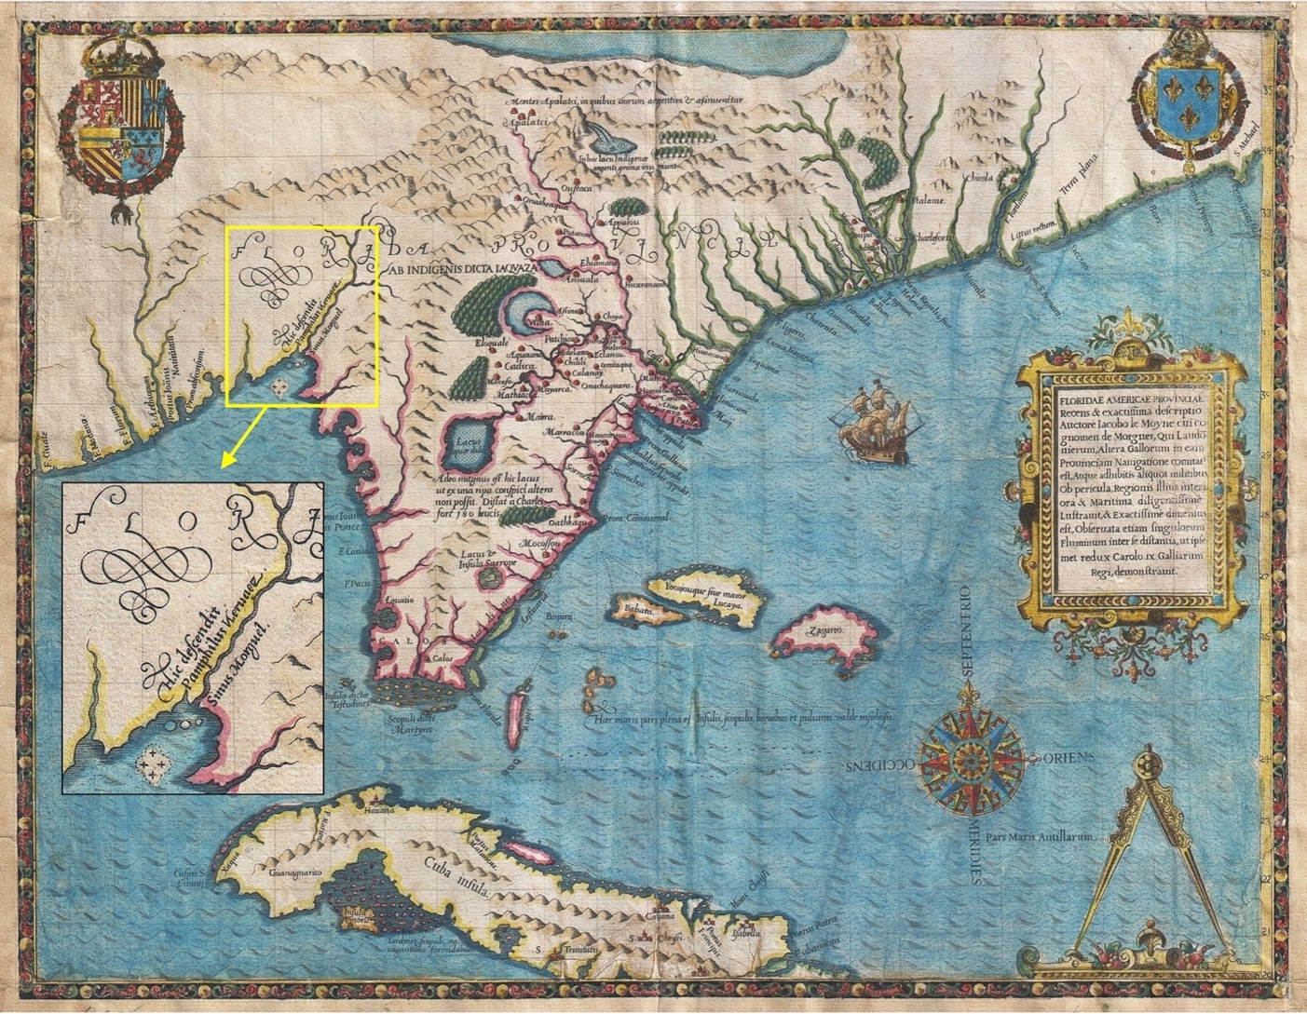
Fig. 12a. Map of Florida and Cuba by De Bry & Le Moyne, 1591, with excerpt below.
https://commons.wikimedia.org/wiki/File:1591_De_Bry_and_Le_Moyne_Map_of_Florida_and_Cuba_-_Geographicus_-_Florida-debry-1591.jpg

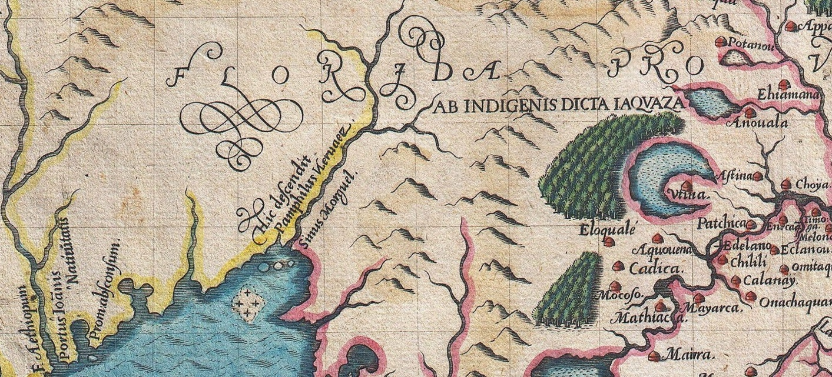
Fig. 12b. “Here Pánfilo de Narváez decended” from the “Bay of Morquel” (the St. Marks estuary).
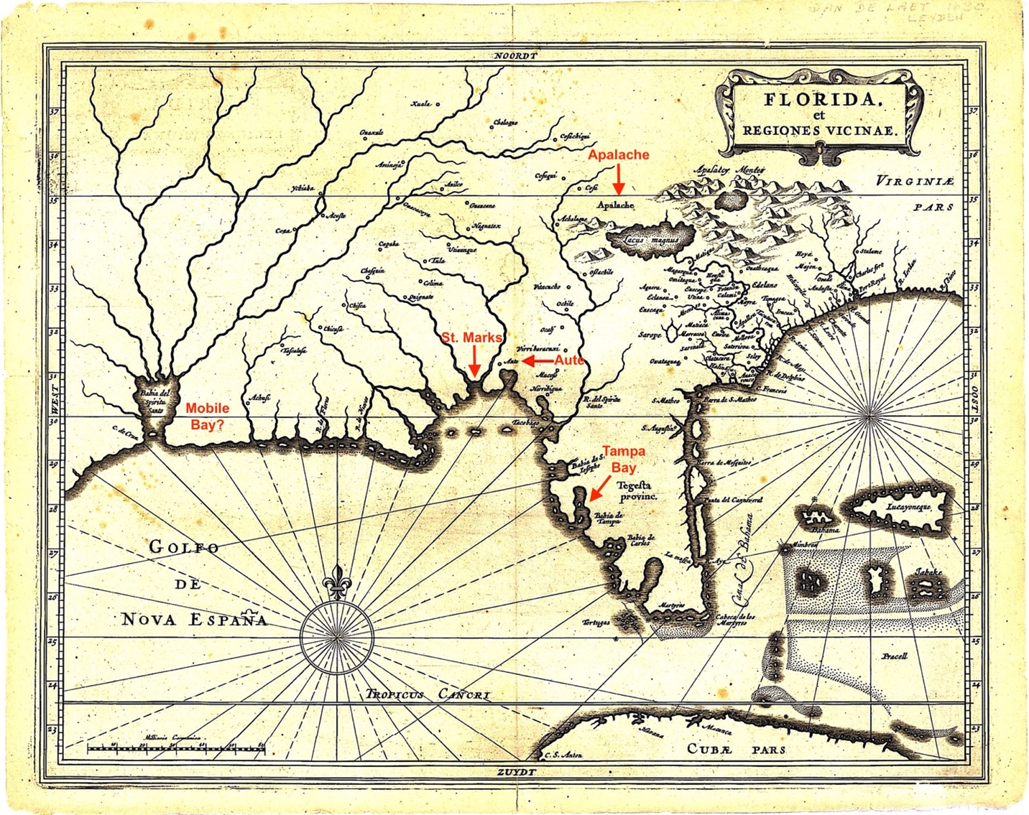
Fig. 13. Location of Aute on 1630-40 map of Florida et Regiones Vicinae by Joannes de Laet.
https://digitalcommons.usf.edu/fl_maps_collection/60/

The following three maps (Figure 14a-c) portray Aute or Puerto de Aute, according to English mapmakers of that time, who freely incorporated labels from earlier Spanish maps. Apparently, Puerto de Aute (Port of Aute) was meant to represent the general location along the St. Marks estuary where the Narváez expedition built boats and staged their escape from Apalache. As navigation improved, maps represented the shorelines more accurately. As individual maps, none of the early ones should be considered the definitive record of where Aute was located. But collectively, they suggest that the village was somewhere along the eastern side of the lower St Marks River. The higher ground that extends close to the estuary there is more favorable to farming—a huge benefit to starving Spaniards who robbed the fields of Aute several times.

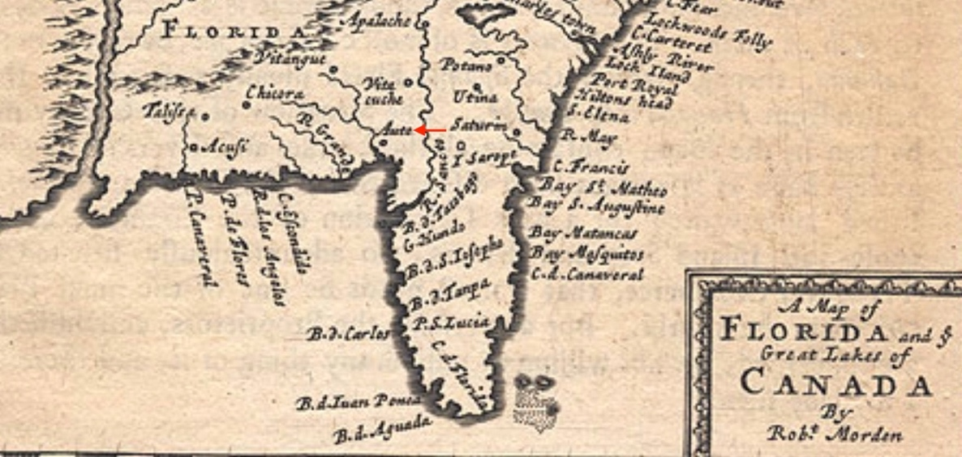
Fig.14a. Aute east of the estuary (Excerpt of Robert Morden,1688).
https://patron.uflib.ufl.edu/UF90000049/00001/citationges

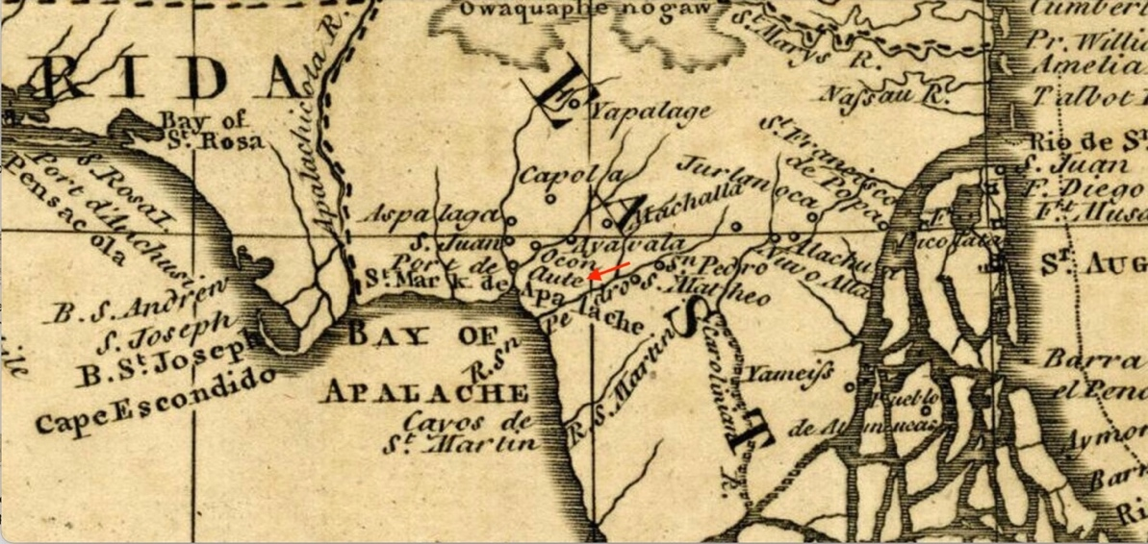
Fig.14b. Puerto de Aute near St. Marks (Excerpt of William Roberts, 1763).
https://www.wwals.net/pictures/1763-01-01--florida-map/fbmany.html

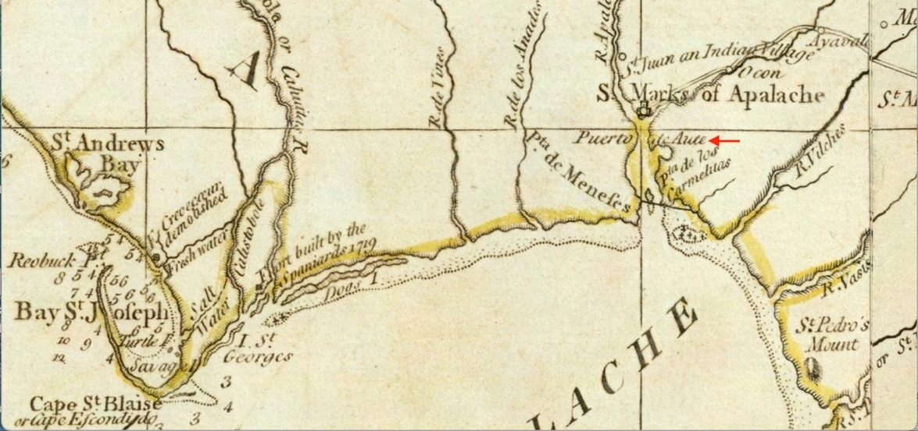
Fig.14c. Puerto de Aute below St. Marks (Excerpt of Thomas Jeffries, 1775).
https://digitalcommons.usf.edu/fl_maps_collection/156).

Figure 15 shows the proposed location area of Aute, with coordinates of a reference point at a bend in the river. The area is most easily reached by boat. The location is about 3.4 miles north (by water) from the river mouth and 1.3 miles south from the Highway 98 crossing. Today, the land in that area is devoted to conservation and tree farming. The sinks and wetlands are mostly within a circular area of slightly lower elevation visible in the LiDAR image (Figure 4).

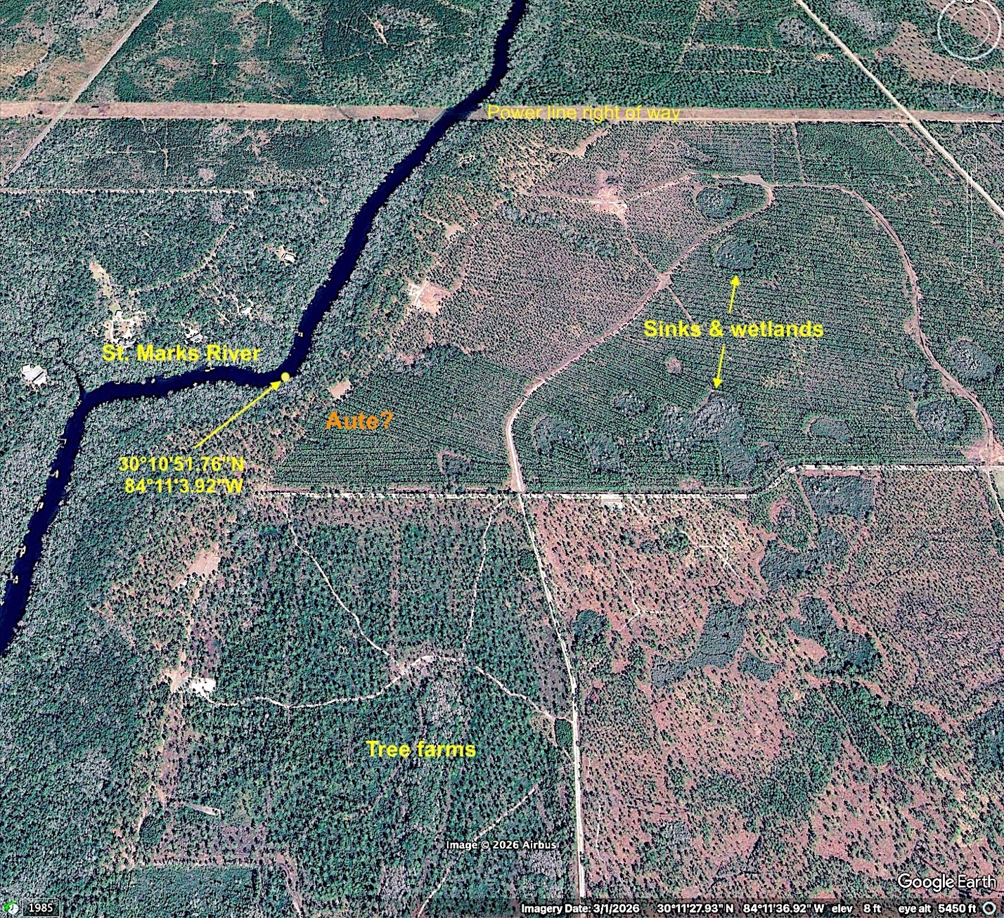
Fig. 15. Proposed Aute site area near the St. Marks River.

Hernando de Soto Expedition, 1539

Eleven years after the Narváez expedition, another led by Hernando de Soto landed near Tampa Bay and may have followed a similar path to the Apalache villages in the hill country of North Florida. His approximate route, better known than that of Narváez, roughly follows the higher ground, as shown on the topographic map (Figure 1). The northern part of the trails approaching the main villages of Apalache very likely skirted the edge of the Cody Escarpment (Figure 2), which was once an interglacial shoreline. Both the Narváez and Soto expeditions had to cross the Aucilla River and its swamps along the eastern boundary of Apalache. Apparently, Soto crossed the upper St. Marks River as well because his army overwintered at the western village of Anhaica Apalache. The chronicler Garcilasco said it “consisted of two hundred fifty large and good houses”, with other significant villages surrounding it.
Although it isn’t clear where Narváez overwintered in 1528, it was more likely at a village on the eastern side of Apalache, which CdV had described as “forty small houses and buildings”, constructed of straw. Perhaps it was the same village that the Soto army passed through and recorded as Ivitachuco.
Archaeological researchers have established that the Soto army spent the winter of 1539-40 at the principal village of Apalache, variously called Anhaica (Elvas), Iniahico (Biedma), or Iviahica (Ranjel). The current De Soto Site Historic Park, where thousands of Spanish artifacts were recovered, is near the Florida State Capitol in Tallahassee.

Note on the Soto chroniclers. The Hernando de Soto expedition of 1539-43 was better organized, managed, and documented than that of Narváez eleven years earlier. Two participants, a Portuguese man self-identified as the Gentleman or Knight of Elvas and the expedition’s factor Luis Hernández de Biedma (the king’s commercial agent) published official accounts. Soto’s private secretary Rodrigo Ranjel also kept a brief but relatively accurate diary of the expedition, which is preserved only through its publication by the contemporary historian Gonzalo Fernández Oviedo y Valdez in his Historia General y Natural de las Indias. Another notable account called The Florida of the Inca was published in five volumes by the Spanish-Inca scholar, Garcilaso de la Vega, some 40 years after the expedition. He relates the reminiscences of a soldier Gonzalo Silvestre, and at least two other participants, Alonzo de Carmona and Juan Coles.
Garcilaso describes Silvestre this way: He was a very fine soldier, performing frequently as a leader; and since he participated in each of the events of the conquest, he was able to supply me with complete details of the history as they occurred. That is overstated; Silvestre could not have been everywhere or witnessed everything all the time. And as recollections after the lapse of many years, the personal stories Garcilaso collected are not regarded as reliable history in many respects, including the accuracy of dates, distances, and sequences of events. However, they do provide interesting details not available from the official accounts. For the most part, these are descriptions of routine—not dramatic or heroic—events, making them seem more credible, if not accurate in every detail. Yet even the strongest memories are fallible, especially after so many years. Garcilaso’s second-hand account is a personal, selective, and anecdotal kind of history; it is largely but not always in agreement with official ones. At least the chronicler of the king, Antonio de Herrera, who had seen the official accounts and reviewed Garcilaso’s manuscript before its publication, was willing to confirm its basic truthfulness.
The expedition was also lucky to start out with a trusted interpreter, Juan Ortiz, a Spaniard captured from a Narváez vessel 11 years earlier. Besides speaking the Uzita and Mocoso languages around Tampa Bay, he was no doubt a helpful bridge to interpreters of other languages, such as Apalache. Consequently, Soto had better access to local intelligence than Narváez did. Native advice and guides surely helped them to navigate the trail systems of the province, including the route to the Bay of Horses campsite.

While some of the Soto forces were exploring the area around the Apalache villages, a detachment of 40 horsemen and 50 foot soldiers led by Juan de Añasco was sent to look for the coast. According to Garcilaso’s account:

Marching six leagues a day for two days along a very excellent road, both wide and flat, these men, after crossing a couple of small and easily forded rivers, came to a village called Aute [or Ochete by Elvas]. Finding the place uninhabited but well stocked with food, they provided themselves with sufficient rations for the next four days and continued their quest along the same fine road.

Their rapid progress over an “excellent road, both wide and flat” raises a question: Why did it take the Narváez troops over a week to cover a similar distance (assuming ~40 miles by trail)? Apparently, the Soto men were in better physical condition and weren’t attacked along the way. Also, maybe the northern half of the route from Anhaica to the St. Marks River crossing (Figure 2) was a superior road and more heavily trafficked, especially after the Narváez invasion. Long after the hated Spaniards had finally sailed away from the Bay of Horses, many Apalache people would likely have visited the ruins of their campsite. They would naturally want to pick it over and sate their curiosity about those strange men who had come out of nowhere and brutalized them for no good reason. Perhaps their leaders decided it would be prudent to keep a close watch on the coast in case the Spanish ever returned by sea, and the “excellent road” the Soto men used was a result of that.
The Soto route from Anhaica, before it joined the Narváez one from eastern Apalache, would have crossed the St. Marks River at some point. I propose they did so unwittingly at Natural Bridge (Figure 5), where the river goes underground through a limestone cavern for about a quarter-mile, and the bordering swamps are relatively narrow (Figure 15). No doubt this was a prominent trail crossing long before the Spanish invasions, as it has been ever since. A Civil War battle was fought over it, and Natural Bridge Road crosses there today. Just south of it, the river reemerges as first-order springs, the so-called River Rise, that flows through a 100-yard-wide channel for nearly a mile. Below that, it narrows to a quarter of that most of the way to St. Marks.
The Soto party did not mention the broad St. Marks River Rise area. They were on a mission to reach the coast, and it was probably not visible from the trail paralleling it. After they arrived in Aute, a native guide they had brought with them proved to be treacherous. He led them astray through rough terrain for five days, supposedly toward the coast but never near it. The Spaniards finally came to blows with the guide and killed him. Fortunately, another native they had captured and brought along from Aute agreed to guide them back there. In Aute, they picked up two more natives, and those three easily led the Spaniards to the Narváez boat-building site at the Bay of Horses. According to Garcilaso’s account:

On the following day, all three Indians led the Christians along a peaceful, flat and open road which lay through some large and good stubble, and which became even broader and more open when it emerged from the stubble. Along the whole of this route they failed to encounter a single difficult passage, with the exception of one narrow swamp which was easy to cross because the horses did not sink even to their pasterns in the mire. When they had traveled a little more than two leagues [~seven miles], they came to a very broad and spacious bay which they skirted until arriving at the place where Pánfilo de Narváez had camped…

The ”one narrow swamp” could have described any small stream or inlet that drained through the forest into the lower St Marks River, such as Port Leon Creek (Figure 6).
Garcilaso continues with a description of the Narváez expedition’s remains at the campsite, and the native guides’ attempts to describe the boat-building project through an interpreter. The Spaniards looked in vain for any messages left behind by the Narváez party.

But they found no such messages, and their efforts completed, they continued along the coast of the bay to the sea, which lay three leagues [~10.5 miles] distant. There they discovered some old canoes which had been grounded, and when the tide was low, 10 or 12 swimmers rowed out to test the depth of the bay in the middle of its channel. Finding it capable of receiving heavy vessels, they placed signs in the tallest trees of the vicinity so that anyone who might be sailing along that coast would be able to recognize the spot. This was the place where Pánfilo de Narváez had embarked in his five ships, which had been so ill-fated that none of them had ever come to light again.

The historian Fernández de Oviedo Gonzalo (using Ranjel’s diary) gives a similar account:

Three Indians guided them by a clear level road, open, with no bad passes, without narrows or marshes, and easy to travel without miring the horses. Having traveled a little more than two leagues, they arrived at a bay, very broad and spacious, and traveling along its banks, arrived at the place where Pánfilo de Narváez had been encamped…
They then followed the bay shore to the sea, which was three leagues from there, and at low tide ten or twelve swimmers went out into the bay in some old canoes that they found, and sounded its depth in the middle of the channel, and found it sufficient for large ships. They put up signs so that anyone coasting might recognize the place, which was the same where Pánfilo de Narváez embarked in his five boats.

We can’t know whether the “coast of the bay” and the “bay shore” they reported following to the sea was literally the marshy bank of the estuary or the forest/marsh boundary that led there indirectly. Perhaps the coastal marshes were less expansive at lower sea levels in the 1500s (see Note, p. 15). However, if they tried to follow the marshy edge of the estuary, it would have been a difficult slog through the flooded tidal zone. Also, they would have had to cross or circle around several large inlets, including the East River Inlet, nearly a half-mile wide at its mouth (Figure 16). Instead, I suggest their three native guides from Aute would have known of a forest trail that led directly eastward and connected with another heading southwestward down the peninsula of higher ground to Lighthouse Point. Unlike the Narváez recon party with no guide, the Soto men did not have to guess at a route to the coast. They may not even have known they were not following the estuary but circling around the vast marshes.
From the descriptions above, the channel they found near the open coast that was “sufficient for large ships” can only be at Spanish Hole close to Lighthouse Point, where the Soto ships later anchored close to shore. (With reference to the maps in Figures 12b and 13, also note the three islands off the St. Marks estuary, which “Pánfilo de Narváez decended.”)

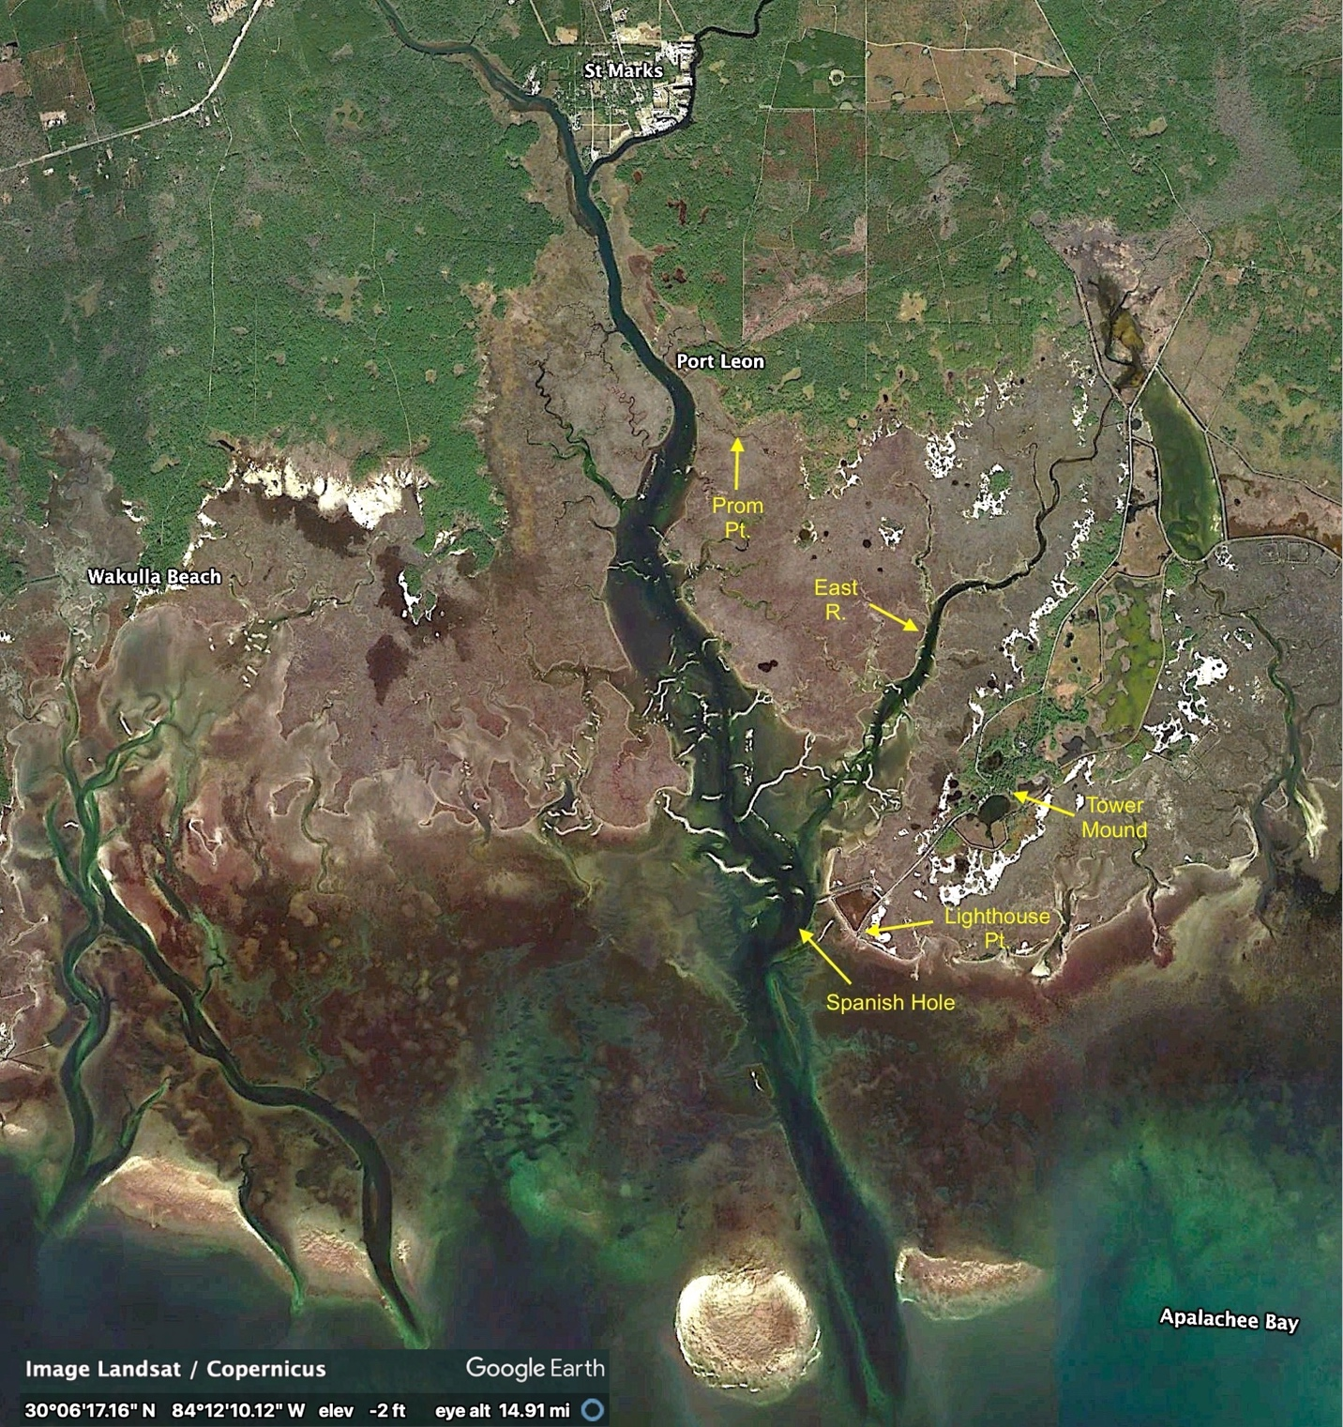
Fig.16. Spanish Hole, the deep anchorage close to Lighhouse Point.
Note the river channel extending offshore and the three islands first mapped in 1591 (Fig. 12b, 13).

The ancient river channel, which extends well offshore of the St. Marks estuary, was probably eroded into the limestone bedrock during the glacial periods of extremely low sea levels There is no other place along this part of the Gulf Coast where Soto’s seagoing ships could have approached and anchored so close to a forested shoreline.

Oviedo, anticipating the arrival of their ships, says:

We made a piragua, which went out every day two leagues to sea, looking for the brigantines [bergantines in Spanish], to show them where to stop.

The distance by water from the St. Marks area to the open coast just off Spanish Hole, is about two leagues (~7 miles). The top end of the estuary near St. Marks is where they likely built the piragua, a large dugout canoe or a simple planked boat that could be sailed or rowed (Figure 17). That would have been the closest access to navigable water from Anhaica. Excellent lumber for it was readily available (also to the Narváez boat builders) from the virgin longleaf pines, up to four feet in diameter. Vast forests of these huge, straight trees once covered the southeastern U.S. (Figure 18). A few such pines still stand near the St. Marks Wildlife Refuge Visitors’Center.

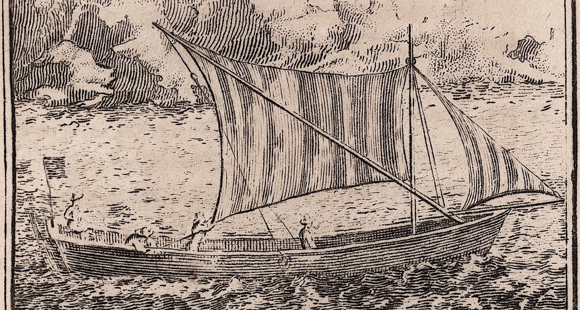
Fig. 17. Excerpt of piragua image, 1742 (The John Carter Brown Library, Providence, RI)
https://benersonlittle.com/tag/piragua/

The Portuguese Gentleman of Elvas reports that:

…the governor ordered planks and spikes to be taken to the coast for building a piragua, into which thirty men entered well armed from the bay, going to and coming from the sea, waiting the arrival of the brigantines, and sometimes fighting with the natives, who went up and down the estuary in canoes.

Presumably, they built the piragua at a temporary campsite—the “camp” that Garcilaso mentions below—at the upper end of the estuary. Perhaps it was near that of the BoH campsite where there were more virgin longleaf pines, and it was close to the estuary for ease of launching.

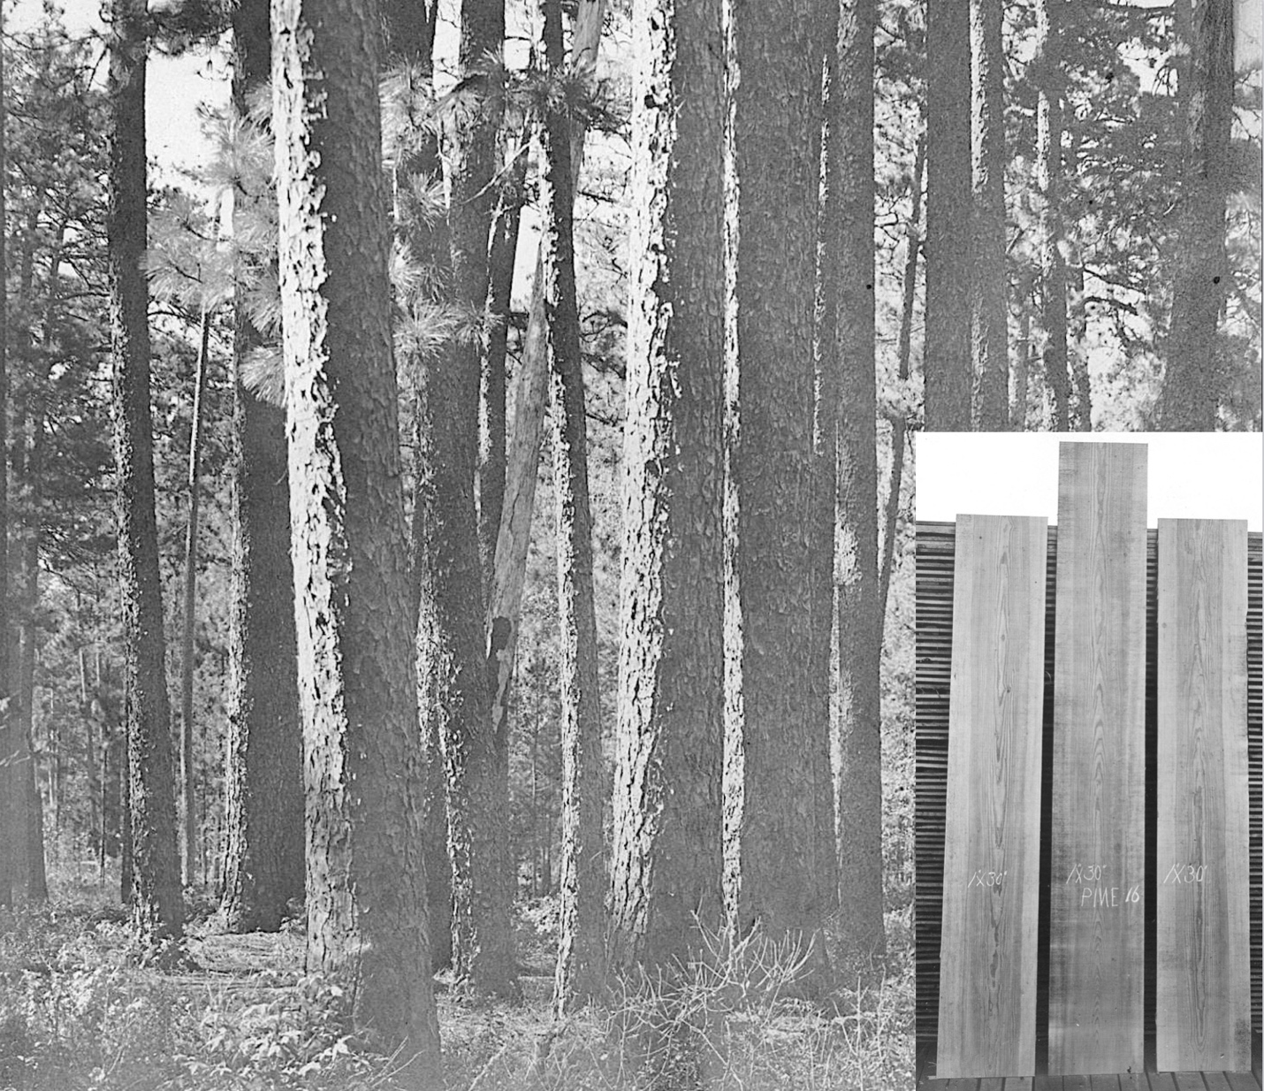
Fig. 18. Virgin longleaf pine forest and 30 inch-wide boards harvested from it.
American Lumberman. [Longleaf Pine Timber, Houston County, Texas - 2], photograph, 1907; (https://texashistory.unt.edu/ark:/67531/metapth204373/m1/1/)

Previously, Garcilaso had said that Juan de Añasco’s 40 horsemen and 50 footsoldiers (including Gonzalo Silvestre), after investigating the Narváez campsite, had explored another three leagues (~10 miles) along the coast of the bay to the Gulf, where they had discovered the deep anchorage near shore and had “…placed signs in the tallest trees of the vicinity so that anyone who might be sailing along the coast would be able to recognize the spot.” He doesn’t mention building the piraguas or their daily runs to the Gulf to look for the two bergantines, maybe because Silvestre—his main source—was not involved in that effort. But he confirms that the ships successfully located and anchored in the port.

…the Comptroller Juan de Añasco, who had gone out from the Bay of the Holy Spirit [Tampa Bay] with the two brigantines to look for the Bay of Aute [St. Marks River estuary], had just six days previously arrived at his destination without having experienced anything at sea worthy of remembering. He had disembarked in Aute [the Bay of] without opposition since the Governor had more or less computed the time required for the trip, and twelve days before he was due, had dispatched one company of horsemen and another of foot soldiers to make safe for him both the port [at Spanish Hole near Lighthouse Point] and the road to the camp. And while at the port, they attached flags to the highest trees where they could be observed from the ocean. Juan de Añasco saw these flags and came with two companies of men to the camp, leaving a good defense, however, on the brigantines which lay at anchor in the bay.

Mitchem (1988) proposed that the St. Marks Wildlife Refuge Cemetery (8Wa15) site (also known as Tower Mound) may be the Bay of Horses campsite, based on numerous 16th-century Spanish artifacts found there along with native burials. The site (Figure 16) is located “on a wide point of land to the southeast of the mouth of the river” (the St. Marks estuary). This is the ridge of higher ground that the Soto detachment under Juan de Añasco had traversed on the way from the BoH site to Lighthouse Point. The Spanish artifacts found at Tower Mound could have resulted from all the Spanish activity up and down the estuary from mid-November to late December 1539, after the two bergantines arrived and anchored at Spanish Hole. The boats soon left to explore the coast westward for two months. They returned to Spanish Hole in late February, before leaving again for Cuba. The whole Soto force finally began marching northward from Anhaica on March 3, 1540.
There should have been ample opportunity during over three months of Spanish presence around the anchorage to interact with the natives at Tower Mound, a little more than a mile from Lighthouse Point. At least some of the Spanish artifacts found there might be trade items from Soto men. It seems less likely they would be from Narváez troops, since their interactions with natives at the BoH campsite were apparently all hostile.
Mitchem also suggests that Aute may be at the Work Place site (8Wa11) on the eastern bank of the lower Wakulla River, where a single sherd of European pottery was found. However, travel from there to the BoH site would have required both expeditions to cross the St. Marks River to reach the eastern side of the estuary. None of the accounts mention crossing any river.
The former boatyard part of the BoH campsite would be the most likely place to find artifacts of Spanish occupation: forge pits with charcoal, iron slag, horse bones and/or teeth, pine pitch, pottery sherds, oyster shells. Saltmarsh soils tend to be anaerobic and neutral, so organic materials such as pine logs buried in the marsh (ramps for boat launching) might be preserved for centuries. Since the 1500s, sea levels have risen as much as 10-12 inches, half of that rise since 1940. Tree remnants of the previous forest edge are seen in the marshes today. At least some of the 1528 boat-building site that was along the original forest/marsh boundary would be in the marsh now. Wherever the present forest edge is closest to a waterway (and much closer in 1528) would be a logical place to search for relics of the BoH campsite.
After they had spent seven weeks building boats and surviving at the campsite, what evidence would we expect to find of their industry and occupation five centuries later? They would have used any non-essential parts of their armament and tack gear to reforge fasteners for the boats, and taken all other useful items with them on the boats. After they sailed away, the local natives would have combed the site for anything of interest left behind. However, some definitive evidence might still be found at the site.

Note on Port Leon in the campsite area. At or near the proposed campsite is the former town of Port Leon, founded by Tallahassee Railroad Company president Richard Call, who aspired to make it the primary hub for transferring cotton from the Red Hills Region of Florida and Georgia to ships anchored off of St. Marks. During 1837–1843, Port Leon grew and prospered with a population of up to 450, and even became the Wakulla County seat. Then the town was utterly destroyed by a yellow fever epidemic in 1841 and a powerful hurricane in 1843. Scarcely any sign of it remains today, aside from the raised railroad bed and old dock pilings along the estuary (Figure 19).

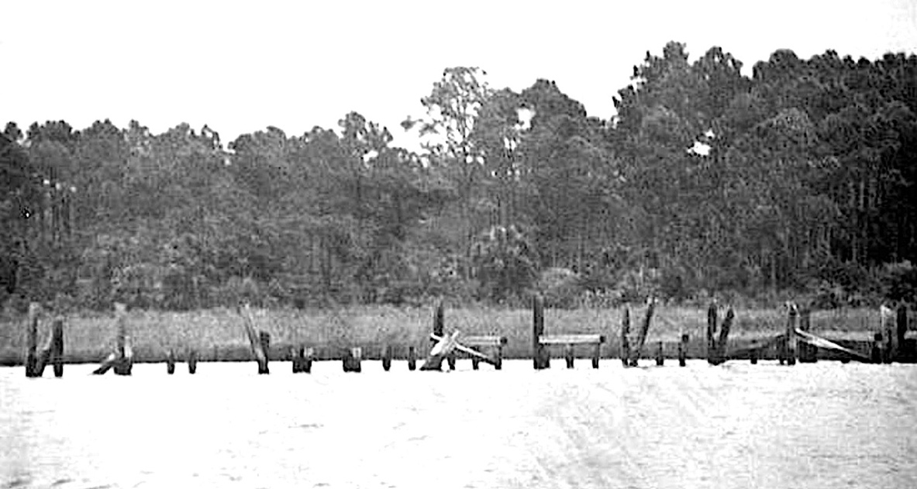

Fig. 19. Remains of the government docks - Port Leon, Florida
Note the close proximityof forest to shoreline.
https://www.floridamemory.com/items/show/40545

In hindsight, the location of Port Leon was as strategic in its day as it was for Soto in 1539-40. In both cases, it functioned as a secondary port where cargoes were exchanged via small boats between ships anchored at Spanish Hole and the terminus of the railroad line (or native trails) leading to the Tallahassee (or Anhaica Apalache). The area of Port Leon seems to have been the best location for linking the hill country above the escarpment with the Gulf of Mexico through the St. Marks estuary.

Appendix

Two 18th-century maps of the St. Marks area (Figures 20 and 22a,b) represent nearly the halfway point in time between the Narváez–Soto expeditions and today. They provide a useful update to those earlier accounts.
In 1760, Spain still controlled Florida, and at St. Marks (San Marcos de Apalache), they had developed a quarry (cantera) nearby to rebuild a previous wooden fort (fuerte) with limestone at the St. Marks-Wakulla Rivers (Rios de Thagabona-Guacara) junction (Figures 20, 21).That overgrown quarry is still evident in DEM (digital elevation model) images today.
Given that global sea levels were even lower in the 1700s than in the 1500s (Kopp, R. E., et al. 2016), the pine forests (bosques) in 1760 grew very close to the shoreline in many areas that are marshes (potanos) today. This would have made it much easier for the Narváez Spaniards to build and launch their heavy ~40-foot boats directly into some inlet or the estuary. At least three of the inlets (ancones) on the 1760 map are still there today, indicating that these are not transient features.

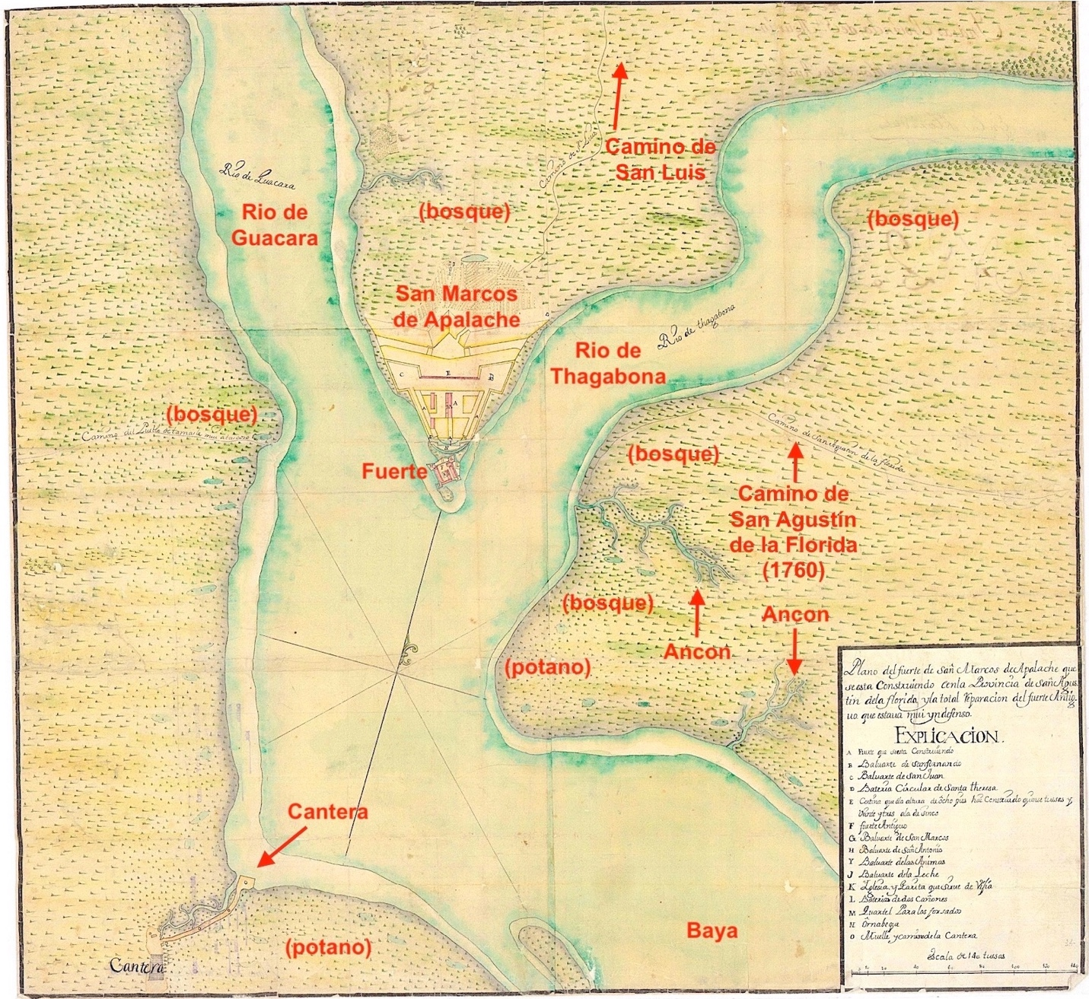
Fig. 20. Spanish 1760 map of the St. Marks area, including the fort and stone quarry.
Ministerio de Defensa, Centro Geographica del Ejercita (Madrid)
https://ejercito.defensa.gob.es/en/unidades/Madrid/ceget/cartoteca/fondos.html

There are also named trails or roads on the map. In the hill country north of the Cody Escarpment, the Spanish had founded a chain of over 100 missions in native villages, from San Luis (once Anhaica) easterly to St. Augustine (San Agustín). They were served by a primitive, ~200-mile road/trail, El Camino Real. By 1760, San Marcos de Apalache was an established town and fort. The map shows two important trails connecting it to the El Camino.
The Camino de San Luis ran for 25-or-so miles due north to the San Luis mission. Another trail at the mouth of the St. Marks (Thagabona) River, the Camino de San Agustín de la Florida, led eastward from the inlet across the river from the fort. Cargoes lightered (ferried) up the estuary from ships at Spanish Hole—at least those destined for the missions— could be transferred from there to either of those two trails. The San Agustín connector must have turned northeasterly and joined El Camino Real, most likely between the St. Marks and Wacissa River swamps, perhaps at the Ivitachuco Mission. Part of it might have been the same route along the St. Marks River that Narváez and Soto followed from the upland villages toward the coast.

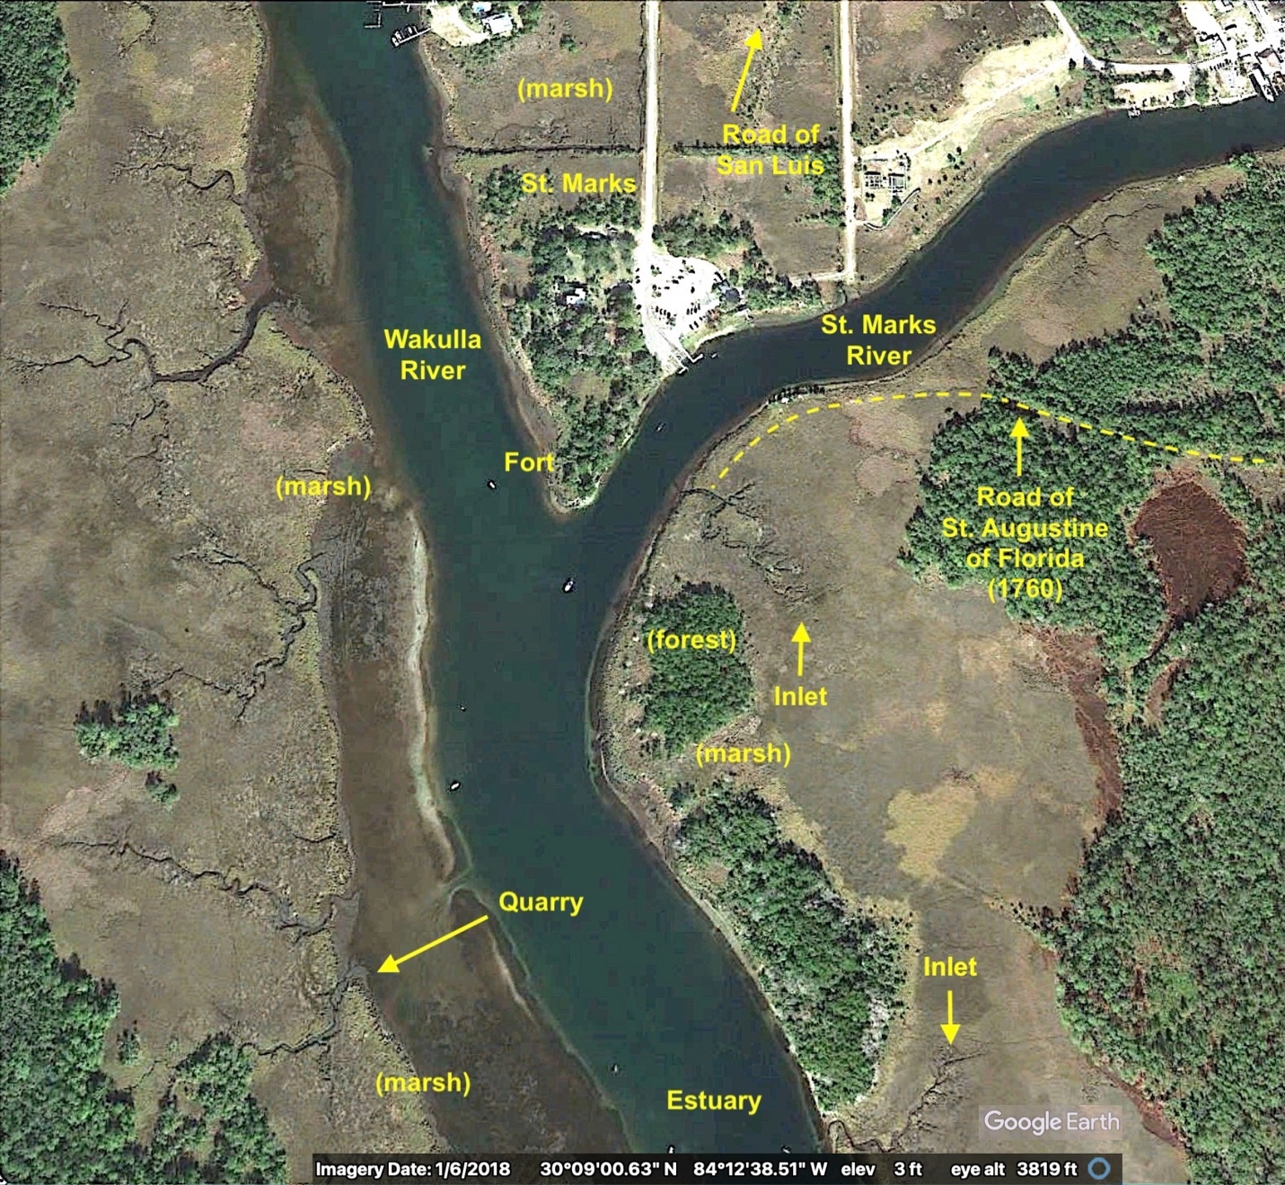
Figure 21. Google Earth January 2018 image of the Spanish map area.
Note the greater extent of forest bordering the St. Marks River and estuary.

The LiDAR DEM image in Figure 4 shows how the topography of that area favors trail access to the St. Marks estuary along the ridge of relatively high ground east of the St. Marks River and north of St. Marks at the river junction. That must have been a long-established native route to the Gulf Coast and the rocky promontory which is now Lighthouse Point.
In 1767, four years after Britain took over Florida from Spain, English surveyor George Gauld and engineer Philip Pittman, made a reconnaissance of the St. Marks area and northward. Their map has interesting details about that landscape two centuries after Narváez and Soto. The northern portion (Figure 22a) shows the main trails from St. Marks to “Talahassa” or “Tonabys Town” (formerly Anhaica) and “Mikisuki” or “Newtown”, a settlement that does not appear to be on the main Road to St. Augustine (El Camino Real). They also note many of the old fields once cultivated by the Apalache and Spanish missions. Opposite the map legend, the comment “here the land begins to be pretty good”, is written at the place about 20 miles north of St. Marks, where the Cody Escarpment rises into the Red Hills. No old fields are noted south of that. It is not clear what features the labels “War Arrow” and “Hurricane Ground” represent.

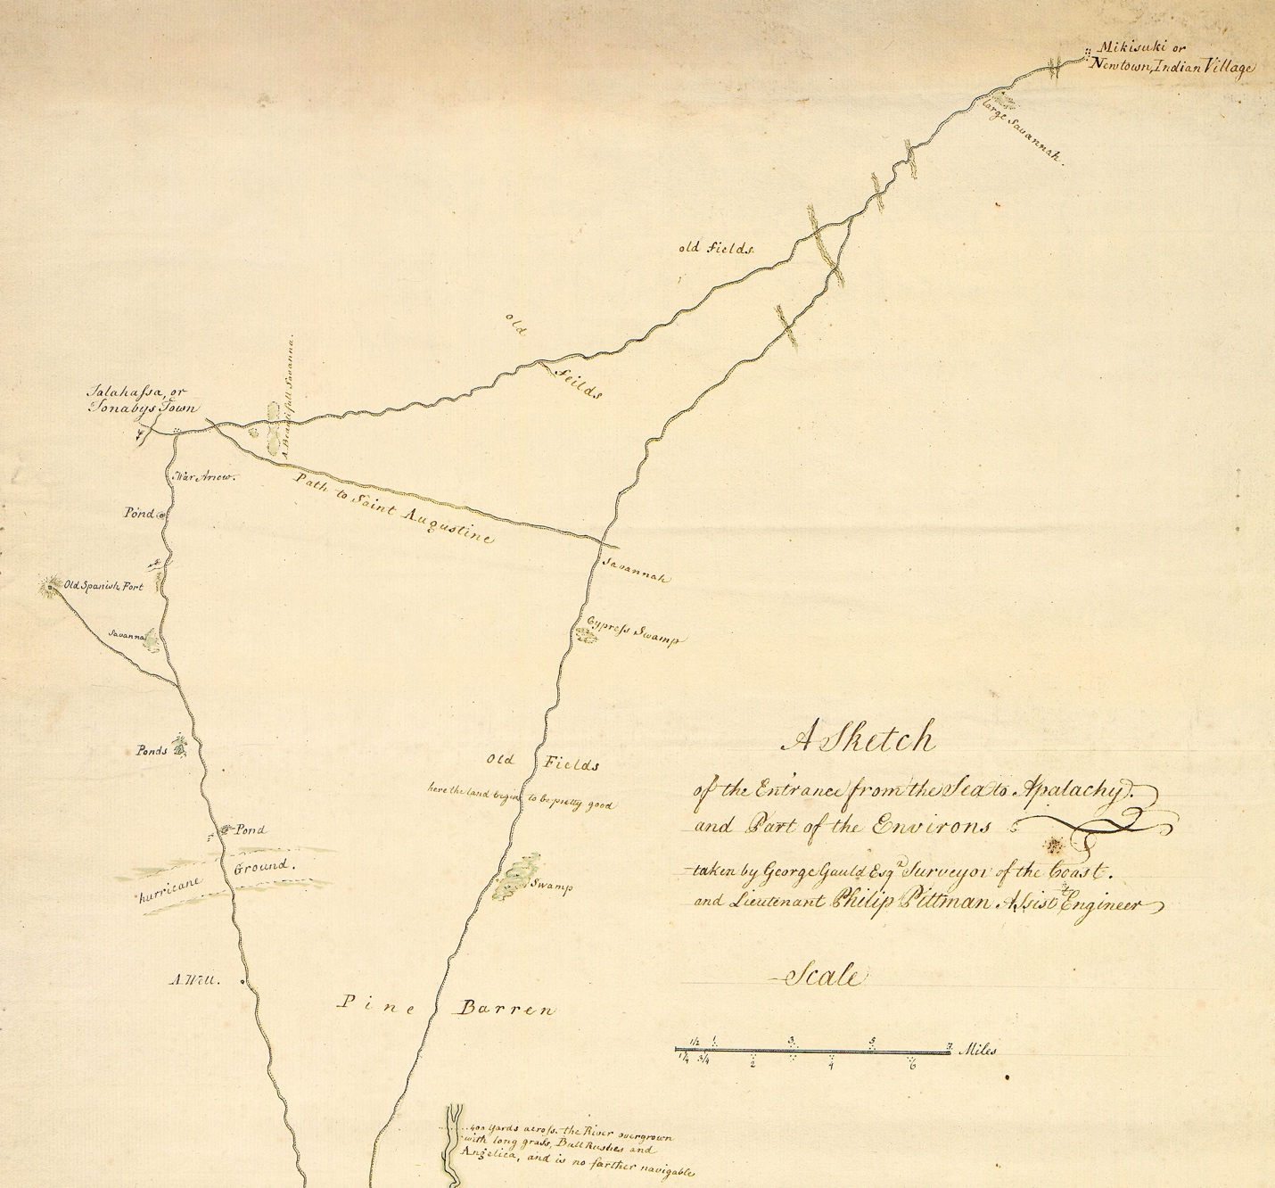
Fig. 22a. “A sketch of the entrance from the sea to Apalachy and part of the environs.” (Gauld, 1767)
William L. Clements Library, University of Michigan:
http://quod.lib.umich.edu/w/wcl1ic/x-865/wcl000959

The southern portion of the same map (Figure 22b) shows the navigable parts of the “NW”(Wakulla) and “NE” (St. Marks) Rivers. At the mouth of the St. Marks was another road to St. Augustine, which likely joined the northern branch from Talahassa to the east. On the east and west sides of both rivers, the landscape is labelled “Pine Barren”, which at that time were forests of virgin longleaf pines with little undergrowth to inhibit travel (Figure 18). Pine barren soils in Florida tend to be sandy and infertile, not so good for agriculture. Yet the evidence points to a location of Aute’s farms being along the lower St. Marks River on a ridge of relatively high ground (~20 ft. elevation or 18 ft. above the river), perhaps where it extends closest to the river (Figure 4). That would have provided the natives with access to water, fish and game, and better flood-plain soils. Interestingly, that proposed location of Aute is where Gauld and Pittman wrote “clear land” on their map, unlike “clear’d ground” they wrote elsewhere. Does that mean it looked to them like a more natural clearing that might have once been farmed? Unfortunately, there was no archaeologist with them.
From that location of Aute, the distance along the river and the forest/marsh boundary to the proposed BoH site—assuming that trail route—is about five miles. Whatever the distance, from the BoH site, the Spaniards were able to carry out several raids on Aute’s food supplies, probably making the round trip on horseback in a day. As mentioned above, two of the Soto accounts describe a two-league (~7-mile) journey from Aute to the BoH site along “a peaceful, flat and open road” without difficulties (Garcilaso) and “a clear level road, open, with no bad passes, without narrows or marshes, and easy to travel without miring the horses” (Oviedo). Eleven years after Narváez, it seems the road to the BoH campsite was much improved for reasons given earlier.

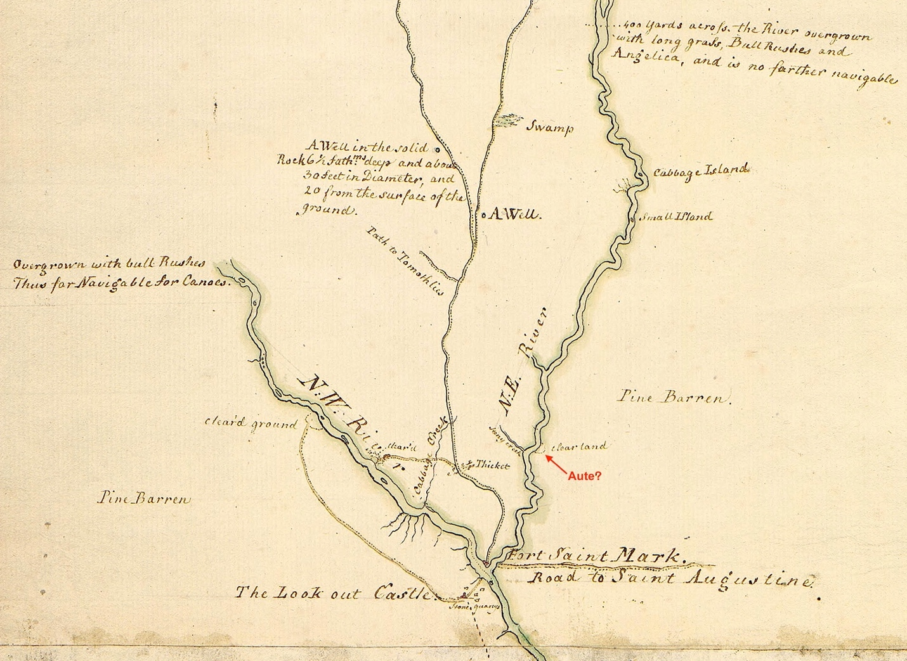
Fig.22b. “A sketch of the entrance from the sea to Apalachy and part of the environs.” (Gauld, 1767)
William L. Clements Library, University of Michigan:
http://quod.lib.umich.edu/w/wcl1ic/x-865/wcl000959

Conclusions

- The Narváez (1528) and Soto (1539-40) expeditions occupied different Apalache upland villages (and chiefdoms?), separated by the upper St. Marks River. The Narváez village (possibly Ivitachuco) was on the eastern side of Apalache; the Soto villages of Anhaica were on the western side.
- The Narváez force traveled on southwesterly trails toward the coast; a Soto detachment traveled on southeasterly trails, crossing the St. Marks most likely at Natural Bridge. At that point, their routes probably converged, and both groups followed similar trails to the Aute village and the Bay of Horses campsite.
- Aute was located on relatively high ground along the eastern side of the lower St. Marks River. Any evidence of the village will most likely be found midway between St. Marks and the Highway 98 crossing (Figure 15). Spanish artifacts are less likely to be present since the Spaniards were there in only brief episodes. Apparently, Aute was still inhabited when the Soto detachment passed through, but they did not occupy the village either.
- The BoH campsite is located in the general area between Prom Point and the former town of Port Leon (Figure 6). At a time of lower sea levels in the 16th century, the forest/marsh boundary of the campsite was very likely much closer to the eastern side of the estuary and to the northern side of Prom Inlet. That would have facilitated building and launching their five boats into navigable water. Physical evidence of the Spaniards’ seven-week occupation of the campsite might still be found, some of it under marshy soils close to the present shorelines of the St. Marks estuary and Prom Inlet.
- The Soto detachment that visited the BoH campsite in 1539 with native guides probably followed forest trails eastward and southward to the present Lighthouse Point, where they discovered the deep anchorage of Spanish Hole. That is where their support vessels reestablished contact with the main Soto forces at Anhaica Apalache. While the vessels were anchored there during a three-month period in 1540, it’s likely the Spaniards interacted with the native inhabitants of the nearby St. Marks Wildlife Refuge Cemetery (8Wa15) or Tower Mound site. Some of the Spanish artifacts found at the Tower Mound site likely resulted from those interactions.
- Supplies from the vessels at Spanish Hole were lightered by smaller boats to the upper estuary and taken ashore, probably near the BoH site or the river junction. The later presence of the Camino San Agustín trailhead at the inlet near the fort (Figures 20,21) suggests that was the place. The piragua that held 30 men may have been built there as well. The importance of that site might explain the “Port of Aute” label on some maps (Figures 14b and c). Garcilaso also called the estuary the Bay of Aute since the name of St. Marks was not used there until the Spanish began building a wooden fort at the river junction in 1679, Fuerte San Marcos de Apalache.
- After five centuries in the St. Marks environment, evidence of the BoH campsite and the Narváez Spaniards may be difficult but not impossible to find. Undoubtedly, some of that once forested area is now tidal marsh due to sea-level rise. Many hurricanes over the years have inundated the area with saltwater and deposited litter. The nearby settlement of Port Leon—though lasting only four years—left non-native artifacts behind. Even so, some definitive evidence of the Spanish presence may still exist, once the site is located. For instance:
- Graves of some 36 Spaniards who died at the site. They might have been covered with limestone or oyster shell. Remains would have to be exhumed to prove they were Spanish. Personal items might be present in graves as well. It seems odd that the Soto chroniclers did not mention noticing any sign of graves at the BoH site.
- Horse (or human) teeth. These should survive burial long after bones are gone. A 16th-century horse tooth found at Puerto Real in Haiti was genetically linked to Iberian horses the Spanish brought to the New World. https://news.ufl.edu/2022/07/oldest-horse-dna-in-americas-supports-folklore/
- Boat launches. The Narváez men would have used pine log skids or rollers to launch their five heavy boats into the Prom Inlet or the estuary. These would be buried in the marsh next to the current shorelines. The anaerobic nature of tidal marsh soils should have preserved them. https://www.antiquelumber.com/about-longleaf-pine/
- Charcoal pits. Lacking heat-stable rocks, the Spanish must have used charcoal pit forges to rework their metal items into fasteners for boat construction. CdV said they made air tubes from sticks and bellows from deer skin. https://www.youtube.com/watch?v=AALf5ADejS8
- Iron slag. If they smelted iron (unlikely) the slag could easily survive burial for centuries. This would be found in the charcoal forges.
- Native pottery. The Spanish might have stolen pottery vessels from Aute. Nothing else would explain finding any pottery sherds of that period with no other evidence of native occupation at the campsite.
- Pine pitch. CdV said the boats were tarred with pine resin prepared by the Greek Don Teodoro. Buried chunks of pitch would survive and might even contain traces of human DNA.
These mundane items of evidence would not have been removed by native people picking through the ruins of the BoH campsite. Of all these, I think the most promising for locating the site would be the buried logs used for boat launching. These boats would have been very heavy, and the Spaniards had few or no horses left when they were launched. Each boat might have had its own ramp, and we know the buried logs would be found along the waterway margins. Surveying those margins with drone LiDAR might reveal some faint linear changes in elevation. Those could be further investigated with GPR (ground-penetrating radar) or ERT (electrical resistivity tomography). All of those methods should be acceptable for permitted use in the St. Marks National Wildlife Refuge.

To conclude, no one, to my knowledge, has looked systematically in the general area of St. Marks and Port Leon for evidence of either Aute or the BoH campsite. The eastern side of the lower St. Marks River is still forested and undeveloped. The National Wildlife Refuge covers the lower mile of it and down both sides of the estuary to the Gulf. Is it surprising that the residents of Port Leon (1839-43) apparently never stumbled on evidence of the Spanish campsite? The first English translation of Cabeza de Vaca’s original account by Buckingham Smith was not available until 1851. It is doubtful Port Leon residents knew much about local Spanish history or would have recognized subtle clues of Spanish occupation, absent finding coins or jewelry.
I believe the BoH campsite can be rediscovered and proven as the boat-building location of the Narváez party. That would be especially appropriate given the approaching quincentenary or 500th anniversary of the expedition in 2028.

References cited

Carson, David. 2021. The Account of Cabeza de Vaca; A literal translation with analysis and commentary. Living Water Specialties, Friendswood, TX. 267 p.

Carson, David. 2022. Children of the Sun; Following in the footsteps of Narváez and Cabeza de Vaca. Living Water Specialties, Friendswood, TX. 507 p.

Church, J. A. and N. J. White. 2011. Sea-level rise from the late 19th to the early 20th century. Survey in Geophysics. 32:585-602.

Garcilaso de la Vega. The Florida of the Inca (Book 2, Part 2). 1951. Translation by John G. Varner and Jeannette J. Varner, University of Texas Press, Austin, TX. 655 p.

Gentleman from Elvas. True Relation of the Hardships Suffered by Governor Hernando de Soto & Certain Portugues Gentlemen during the Discovery of the Province of Florida [Relaçam Verdadeira, 1557]. 1993. Translation by James A. Robertson. In: Clayton, L. A, Knight, V. J., Jr.,and Hoffman, M. P., eds. The De Soto Chronicles; The Expedition of Hernando de Soto to North America in 1539-1543 (2 vols.) University of Alabama Press, Tuscaloosa.

Harris, Steve. 2019. The Narváez expedition barca. Nautical Research Journal. 64(3): 209-224.

Harris, Steve. 2021. Use of the bergantín in sixteenth-century exploration of the New World. Nautical Research Journal. V. 66(2): 111-120.

Hudson, Charles. 1997. Knights of Spain, Warriors of the Sun. University of Georgia Press, Athens, GA. 561 p.

Kopp, Robert E., A. C. Kemp, K. Bitterman, B. P. Horton, J. P Donnelly, W. R. Gehrels, C. C. Hay, J.X. Mitrovica, E. D. Morrow, and S. Rahmstorf. 2016. Temperature-driven global sea-level variability in the Common Era. Proceeding of the National Academy of Sciences. 113(11): E1434-E1441.

La Relación Online. 1555. Wittliff Collections, Texas State University, San Marcos, TX 78666 https://exhibits.library.txstate.edu/cabeza/exhibits/show/cabeza-de-vaca/relacion

Lewis, F. Graham, Nicolas D. Wooten, and Ronald L. Bartel. 2009. Lower St. Marks River/Wakulla River/Apalachee Bay Resource Characterization. Northwest Florida Management District Special Report 2009-01, Havana, FL. 141 pp.

Mikell, Gregory A. and Steven D. Harris. 2023. Modeling the escape craft: What type of vessel did Narváez build to escape the Apalachee and their neighbors? The Florida Anthropologist, V. 76 (1): 1-14. Florida Anthroplogical Society, Tallahassee, FL.

Mitchem, Jeffrey M. 1988. Archaeological and ethnohistoric evidence for the location of Narváez’s Aute. Florida Academy of Sciences Meeting, May 12-14, Tampa, FL. 7 pp.

NOAA Sea Level Rise Viewer, 2022. Digital Elevation Model (DEM); basemap of St. Marks area. (https://coast.noaa.gov/slr/)

Oviedo y Valdez, Gonzalo Fernandez. The Expedition of Pánfilo de Narváez. Translation by Harbert Davenport. Southwestern Historical Quarterly, Vol. 27, 1923-24, in The Portal to Texas History. University of North Texas Libraries, Denton, TX

Reséndez, Andrés. 2007. A Land So Strange; The epic journey of Cabeza de Vaca. Basic Books, New York City, NY. 314 p.

Swanton, John R. 1985. Final Report of the United States De Soto Expedition Commission, House Document No. 71, 76th Congress. Reprinted by Smithsonian Institution Press, Washington, D.C. 400 p.

Wakulla County DEM data, 2018. Northwest Florida Management District, Havana, FL.

Weddle, Robert S. 1985. Spanish Sea; The Gulf of Mexico in North American Discovery. Texas A&M University Press, College Station, TX. 457 p.

Author bio: V. E. Smith is a retired marine scientist who received a Ph.D. at Scripps Institution of Oceanography in La Jolla, California (scripps.ucsd.edu/news/scripps-alumni-spotlight-v-elliott-smith). Following that, he served as a captain in the U.S. Army Reserve in Korea. For most of his professional career he worked on the Great Lakes as an environmental researcher and consultant. Since retiring, he has written three historical novels and maintains a blog about the Narváez expedition of 1527-28: vesmithbooks.com. He currently lives in Boulder, Colorado.

